# Images in the Category: Below 5 Km/h

Image: Test_image_27.jpg

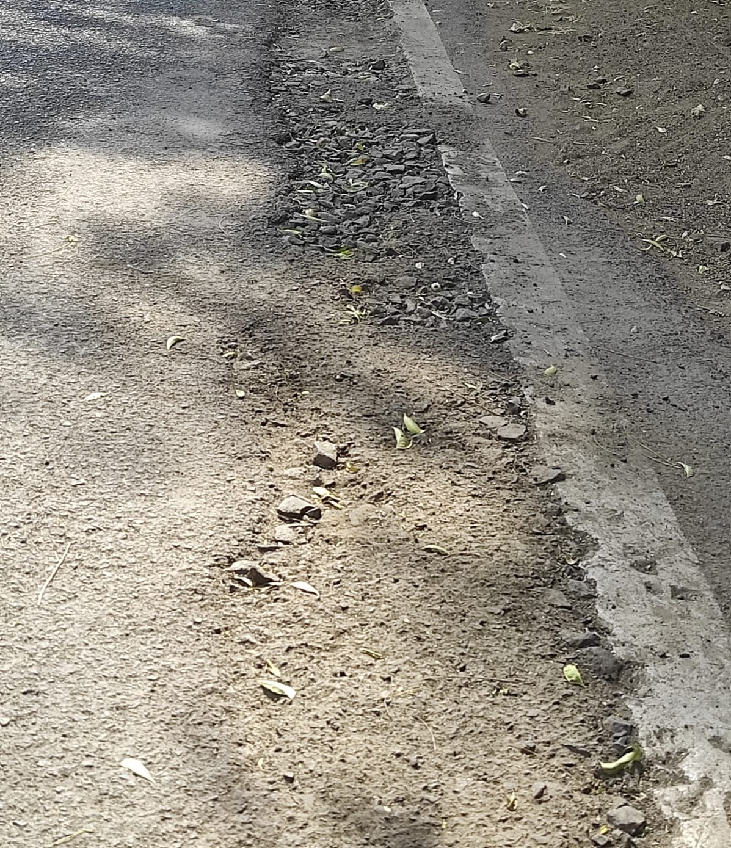

* Predicted Safety Speed: 4.098021030426025 Km/h

Poor road

Image: Test_image_47.jpg

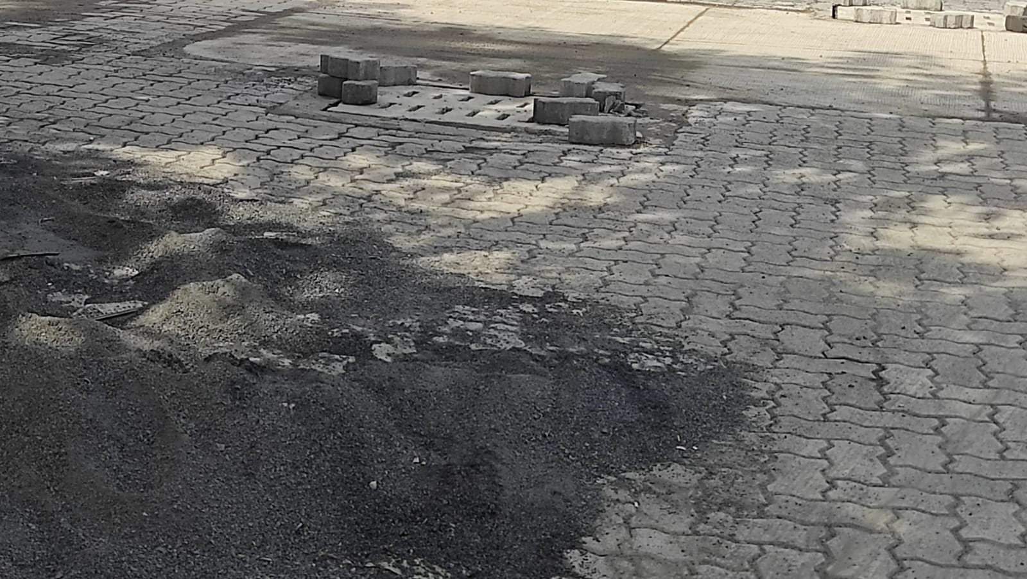

* Predicted Safety Speed: 4.708719253540039 Km/h

Poor road

Image: Test_image_45.jpg

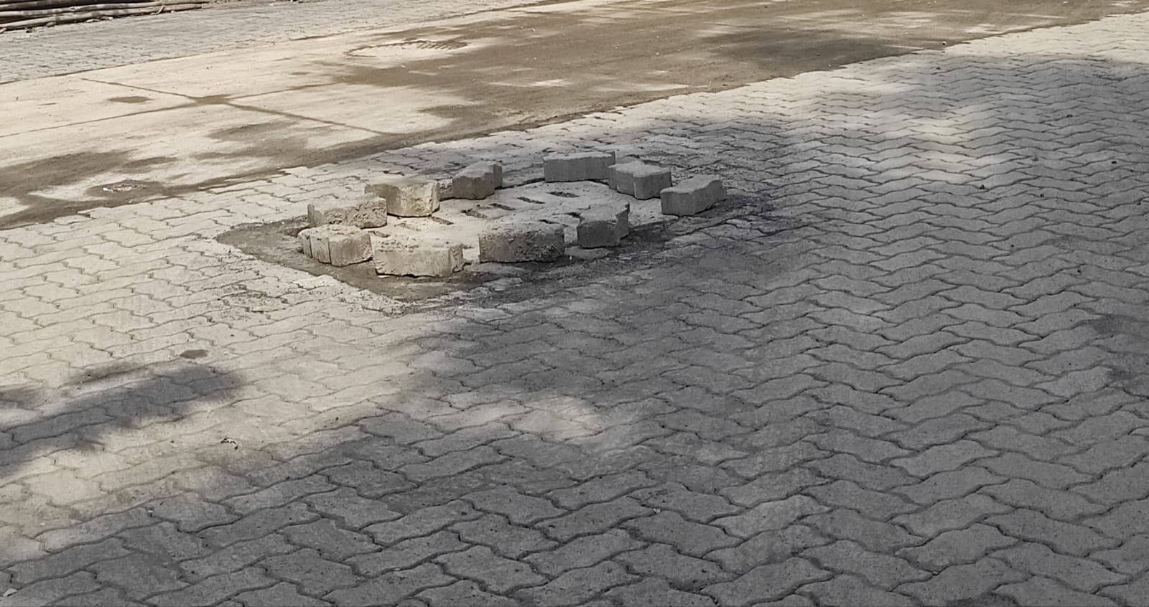

* Predicted Safety Speed: 4.9582438468933105 Km/h

Poor road

# Images in the Category: 5 Km/h - 10 Km/h

Image: Test_image_43.jpg

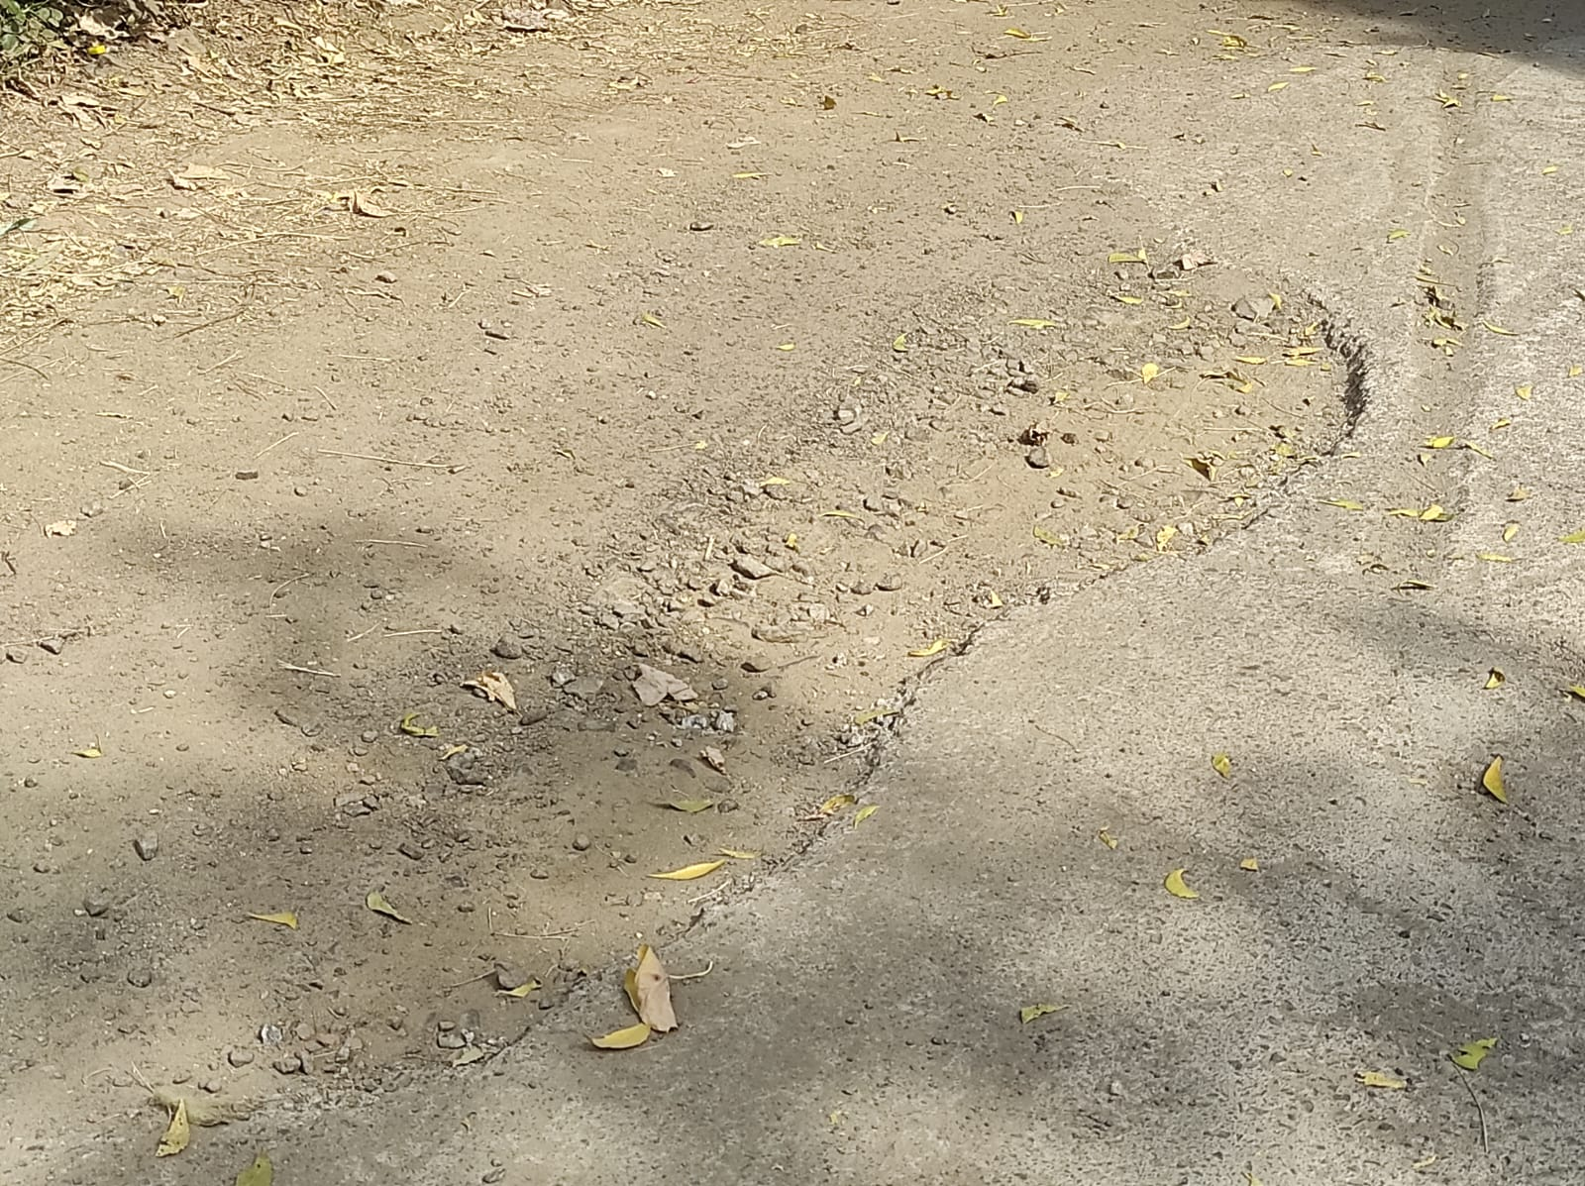

* Predicted Safety Speed: 5.8222246170043945 Km/h

Poor road

Image: Test_image_41.jpg

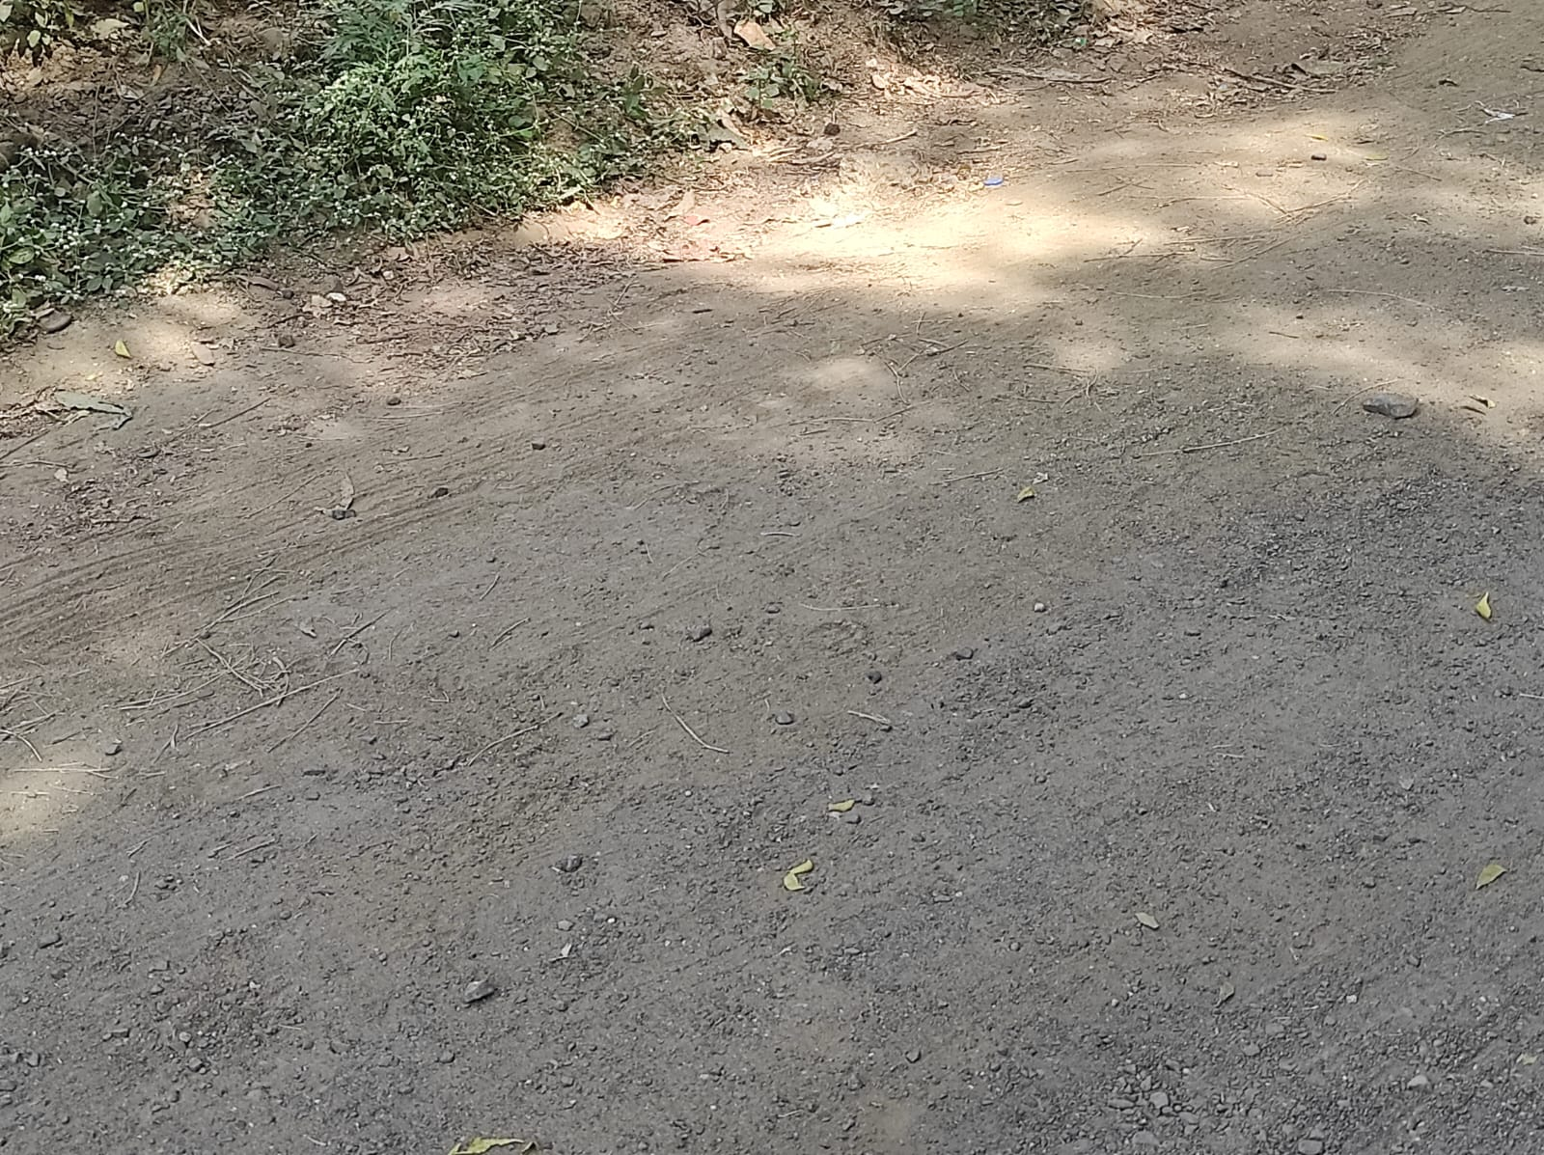

* Predicted Safety Speed: 5.89419412612915 Km/h

Poor road

Image: Test_image_14.jpg

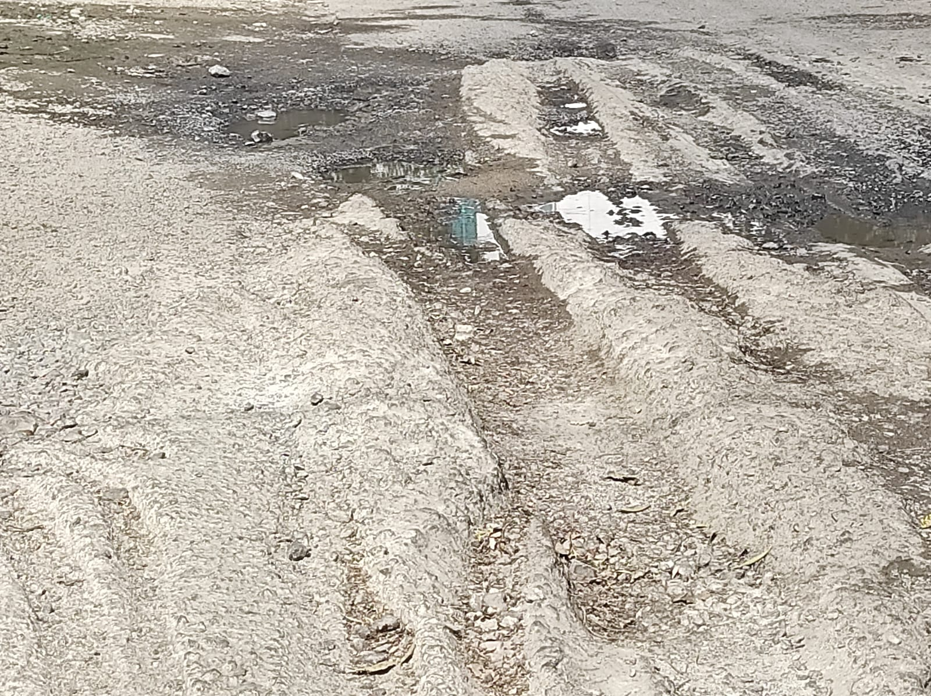

* Predicted Safety Speed: 5.972301006317139 Km/h

Poor road

Image: Test_image_30.jpg

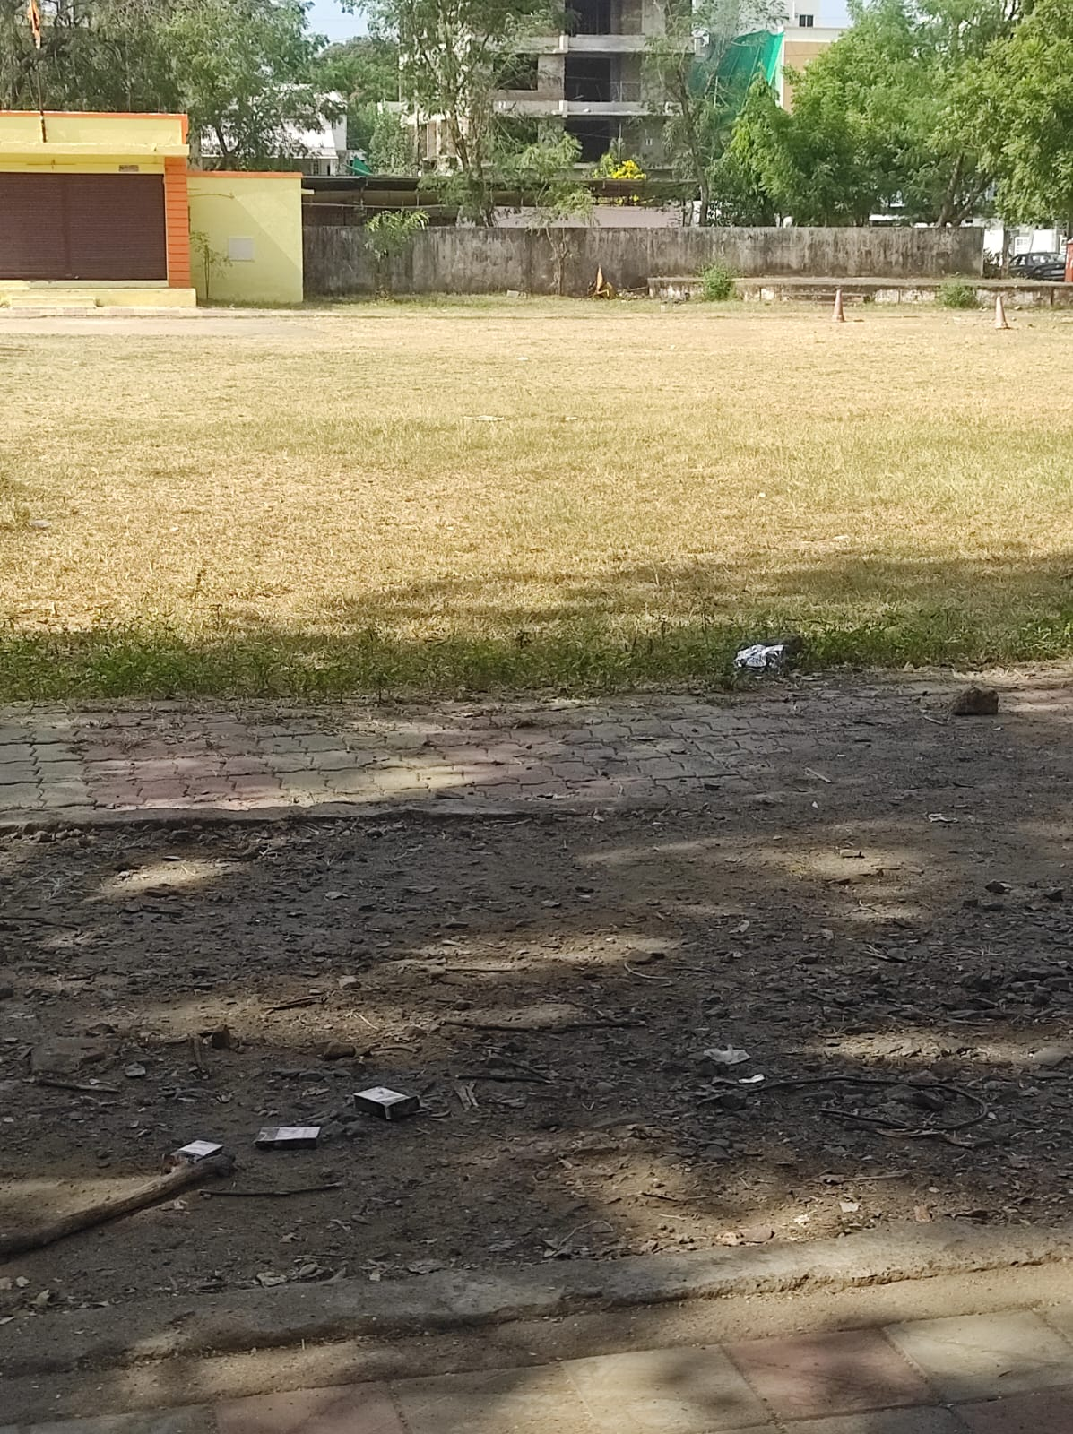

* Predicted Safety Speed: 5.987203121185303 Km/h

Poor road

Image: Test_image_25.jpg

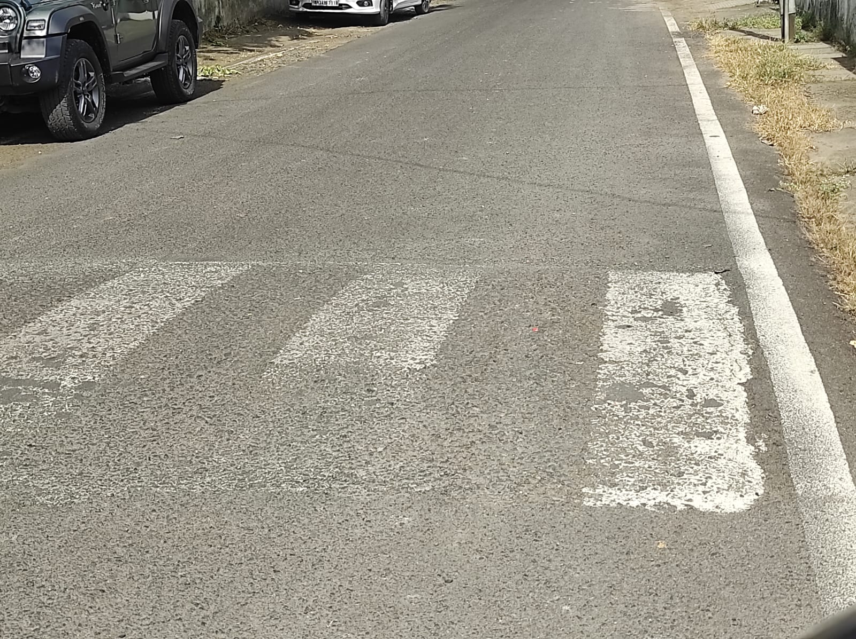

* Predicted Safety Speed: 6.179087162017822 Km/h

Poor road

Image: Test_image_21.jpg

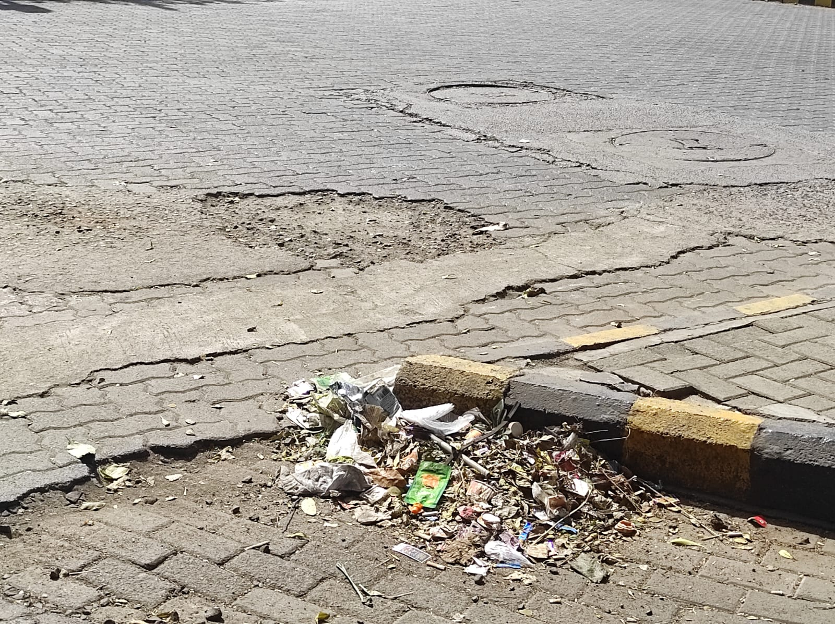

* Predicted Safety Speed: 6.664994239807129 Km/h

Poor road

Image: Test_image_15.jpg

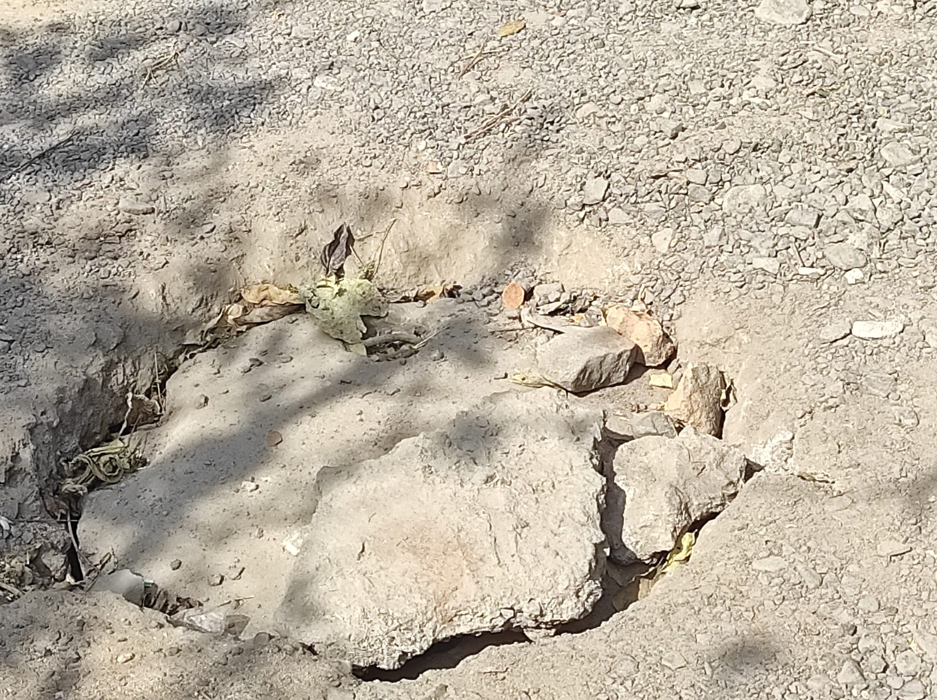

* Predicted Safety Speed: 6.669075012207031 Km/h

Poor road

Image: Test_image_40.jpg

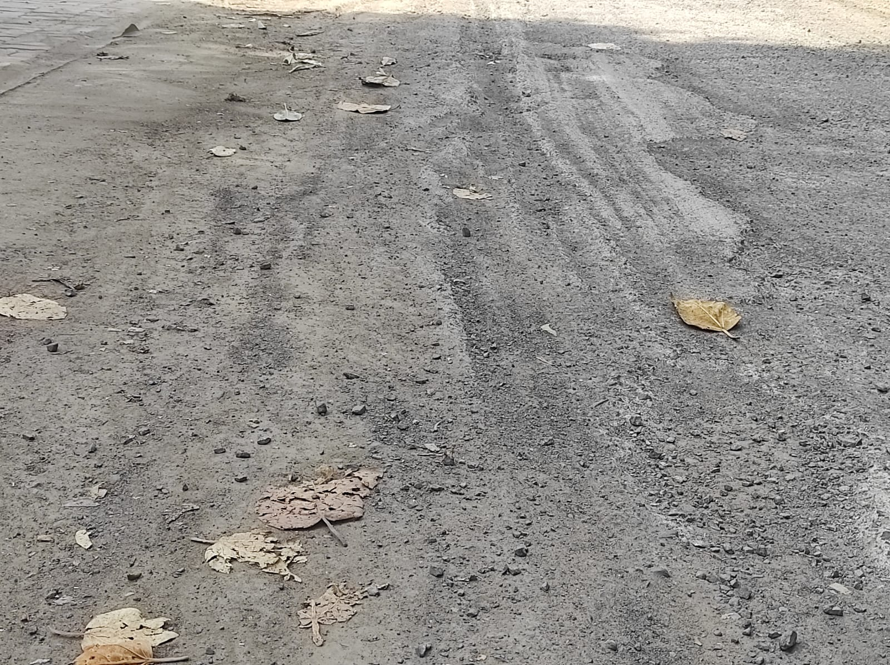

* Predicted Safety Speed: 6.696343421936035 Km/h

Poor road

Image: Test_image_34.jpg

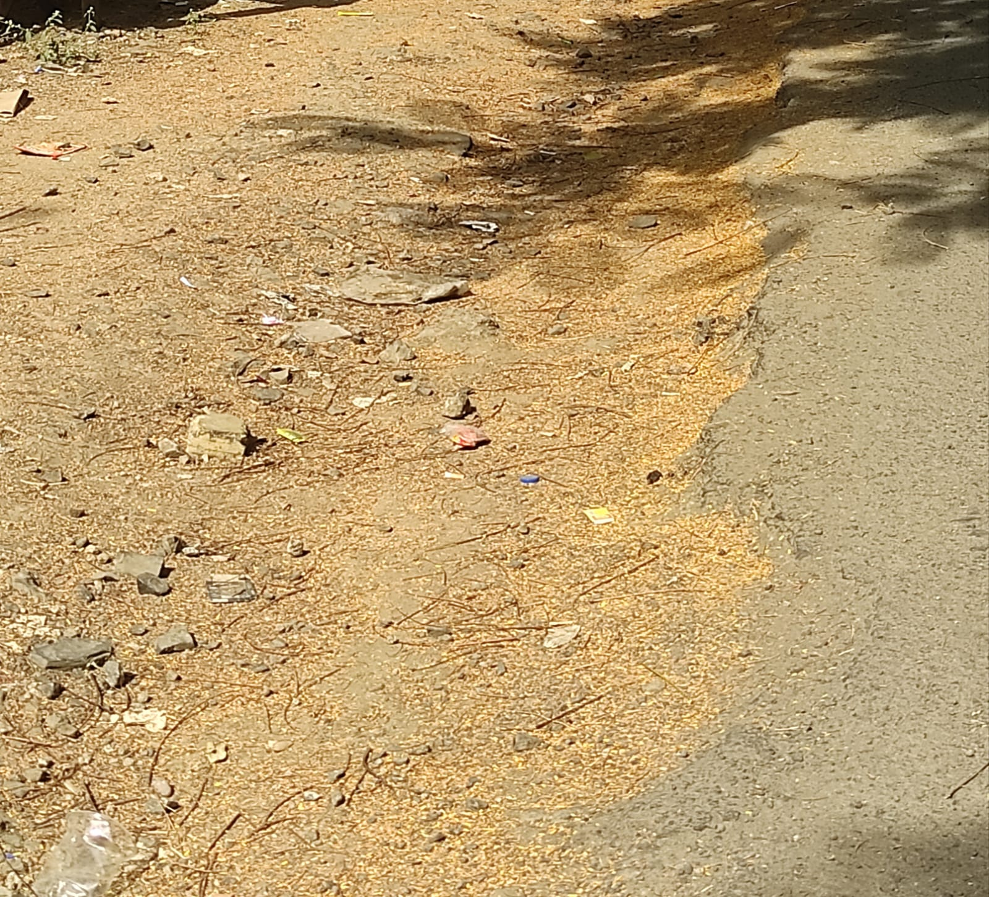

* Predicted Safety Speed: 6.807636260986328 Km/h

Poor road

Image: Test_image_28.jpg

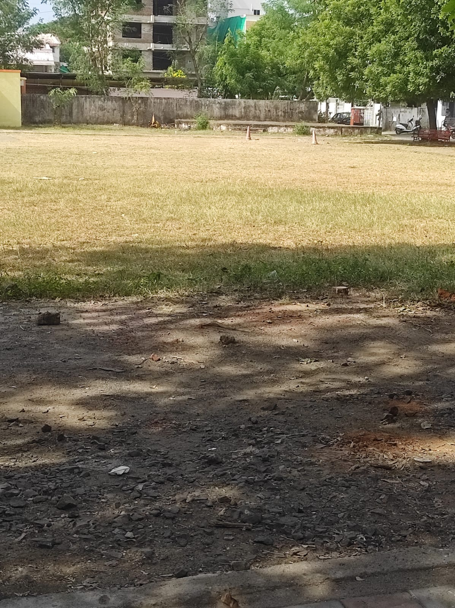

* Predicted Safety Speed: 7.213535785675049 Km/h

Poor road

Image: Test_image_64.jpg

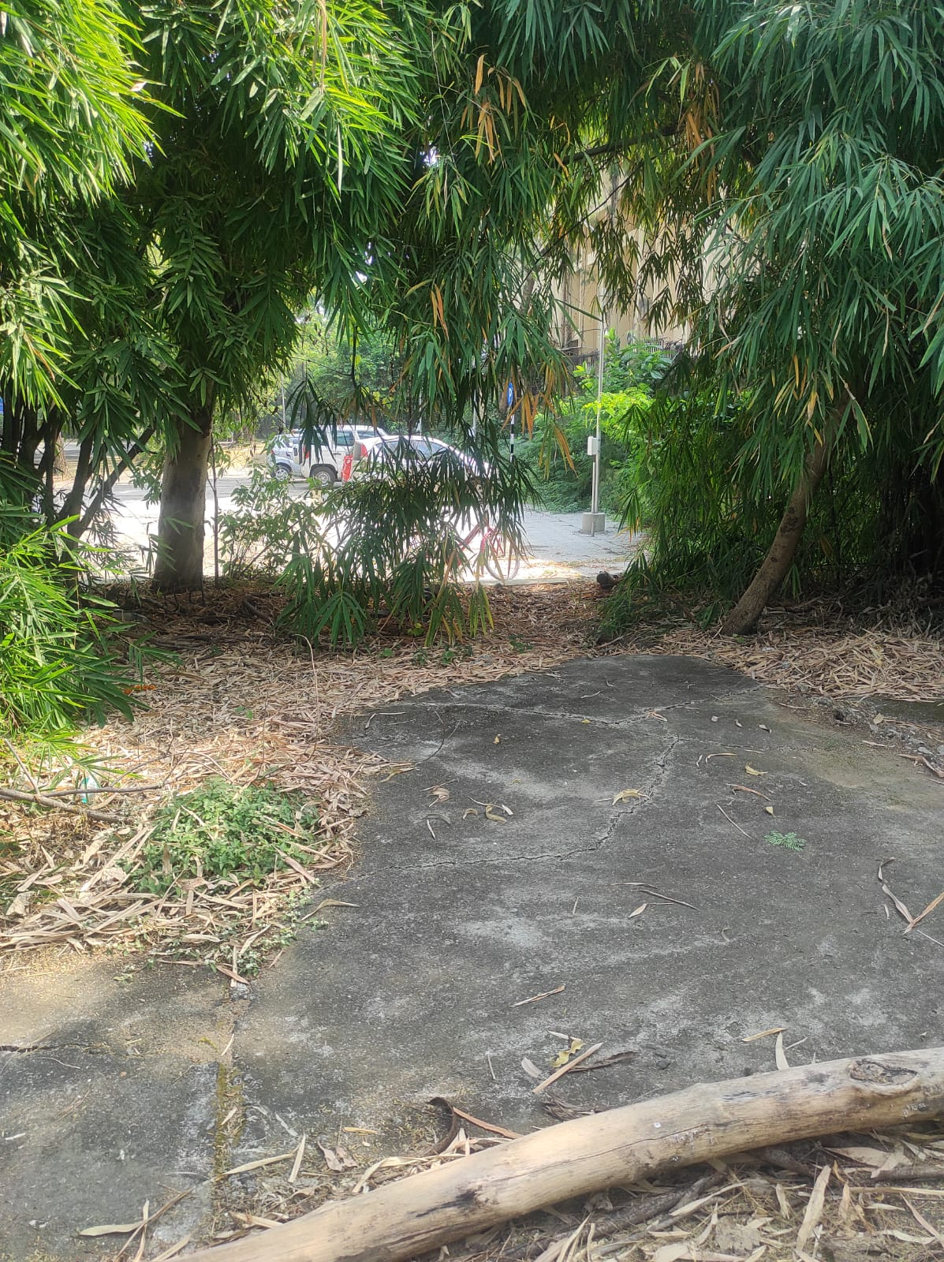

* Predicted Safety Speed: 7.351304054260254 Km/h

Poor road

Image: Test_image_29.jpg

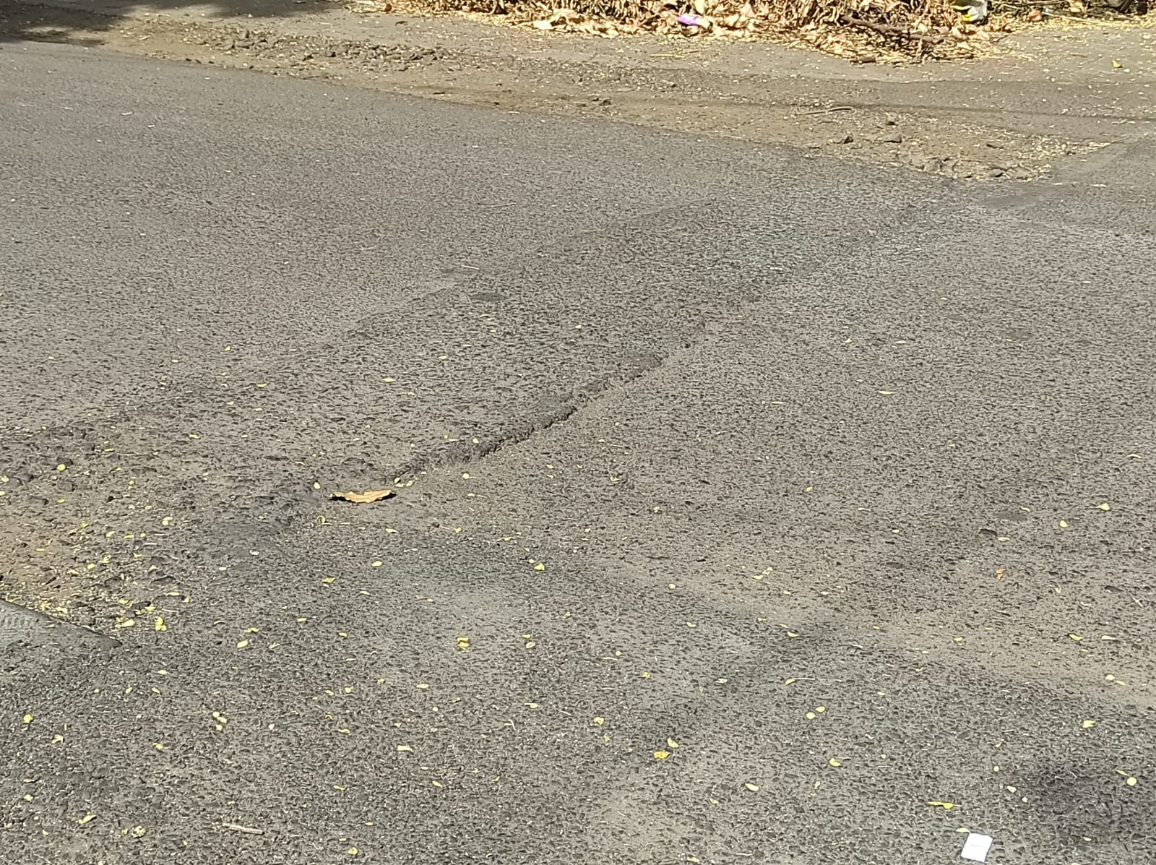

* Predicted Safety Speed: 7.3586297035217285 Km/h

Poor road

Image: Test_image_35.jpg

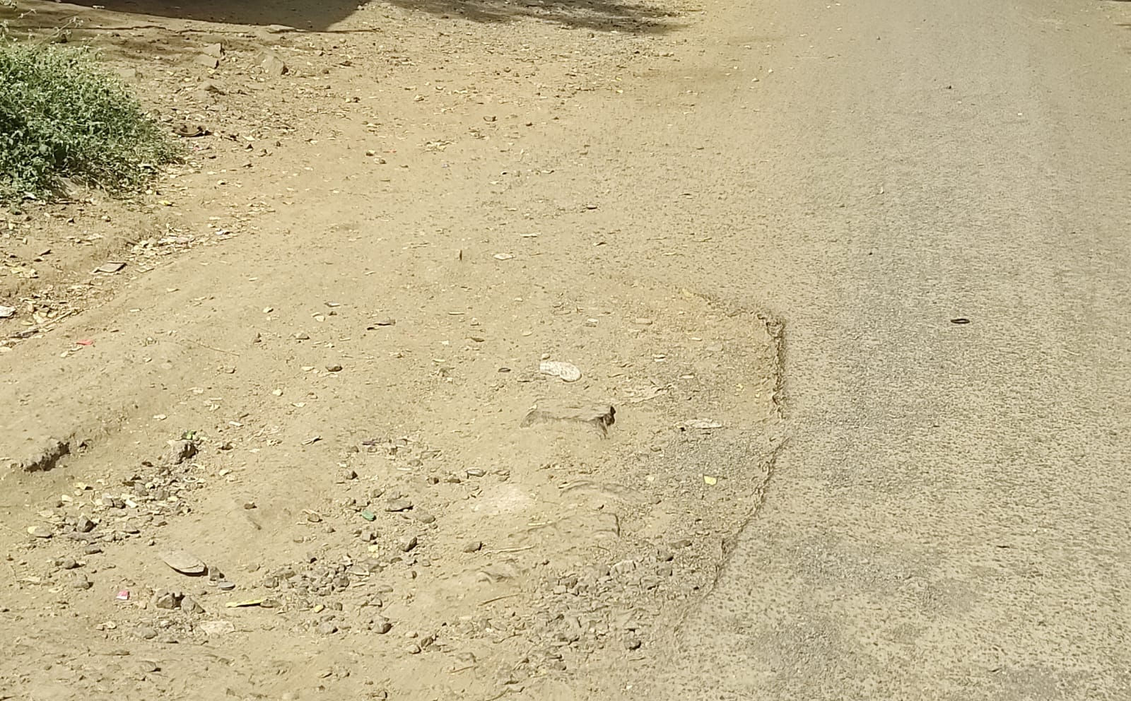

* Predicted Safety Speed: 7.478343486785889 Km/h

Poor road

Image: Test_image_44.jpg

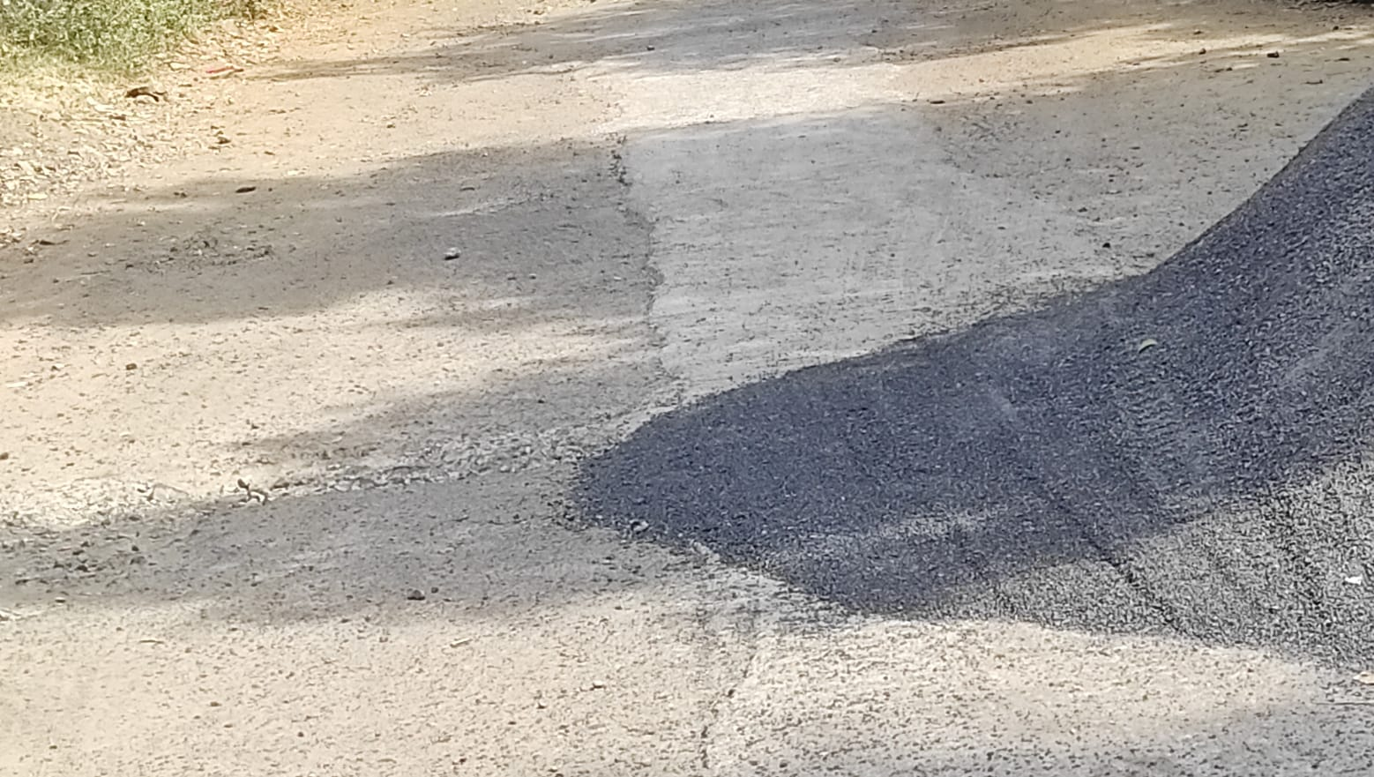

* Predicted Safety Speed: 7.635056495666504 Km/h

Poor road

Image: Test_image_2.jpg

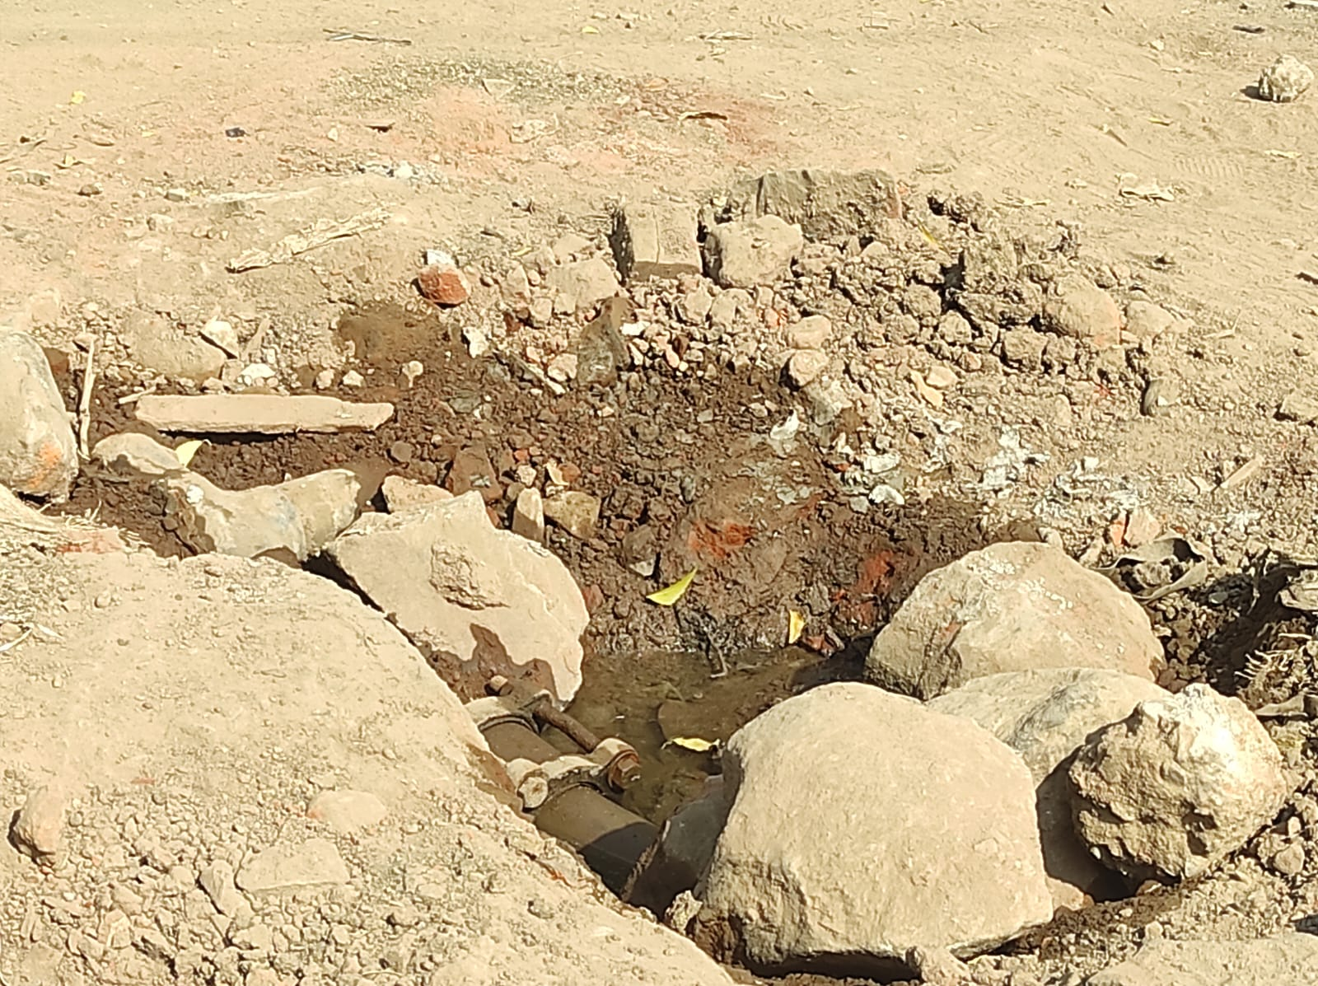

* Predicted Safety Speed: 7.7230544090271 Km/h

Poor road

Image: Test_image_23.jpg

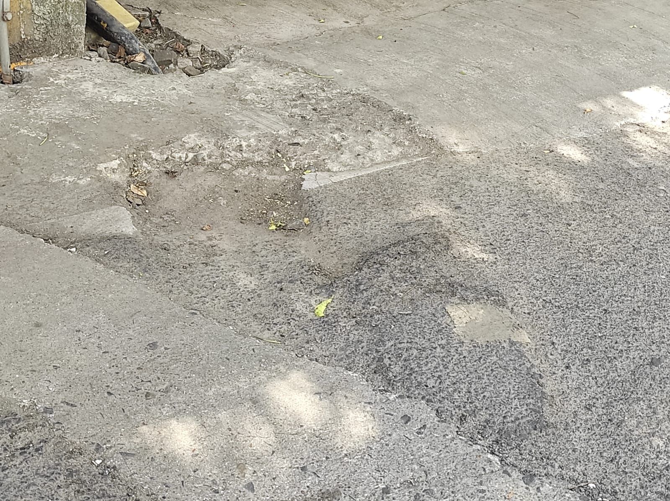

* Predicted Safety Speed: 7.925655841827393 Km/h

Poor road

Image: Test_image_36.jpg

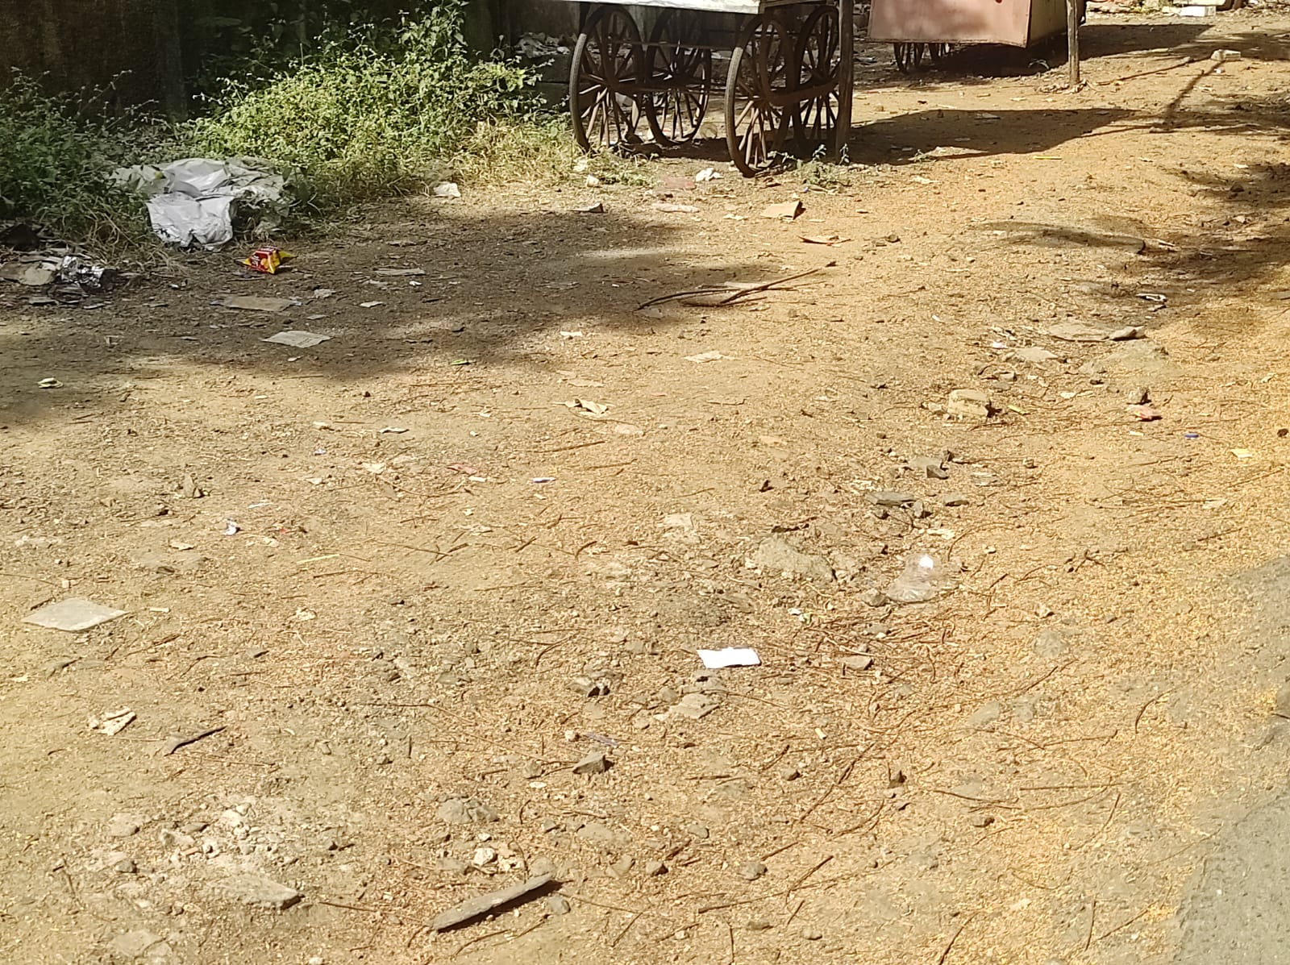

* Predicted Safety Speed: 8.166146278381348 Km/h

Poor road

Image: Test_image_24.jpg

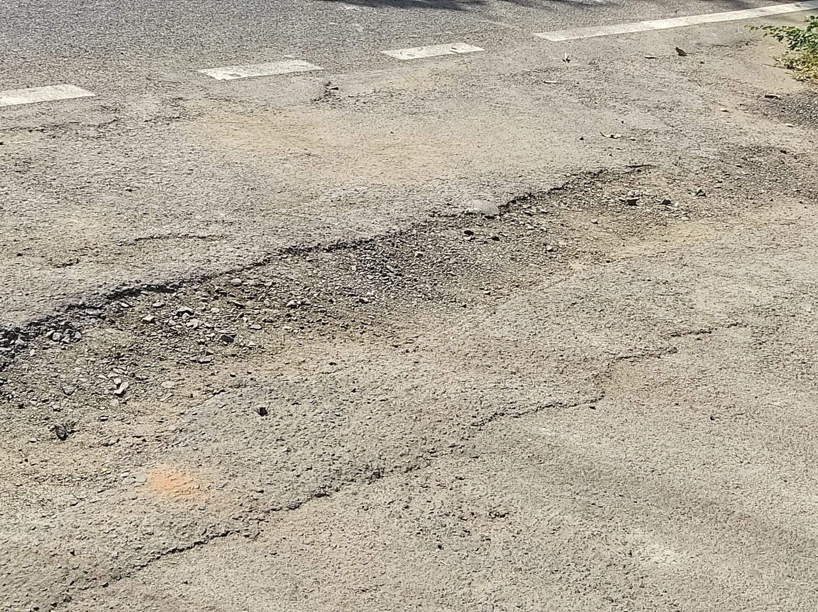

* Predicted Safety Speed: 8.376093864440918 Km/h

Poor road

Image: Test_image_7.jpg

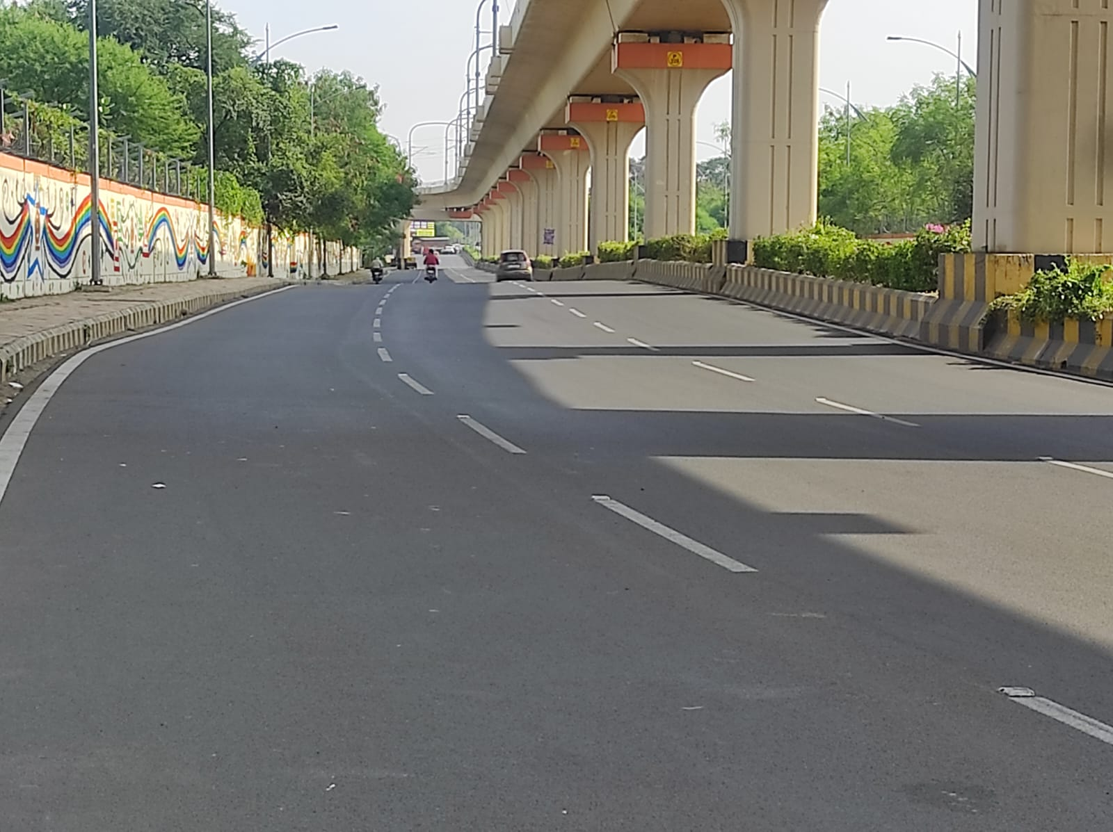

* Predicted Safety Speed: 8.411840438842773 Km/h

Poor road

Image: Test_image_16.jpg

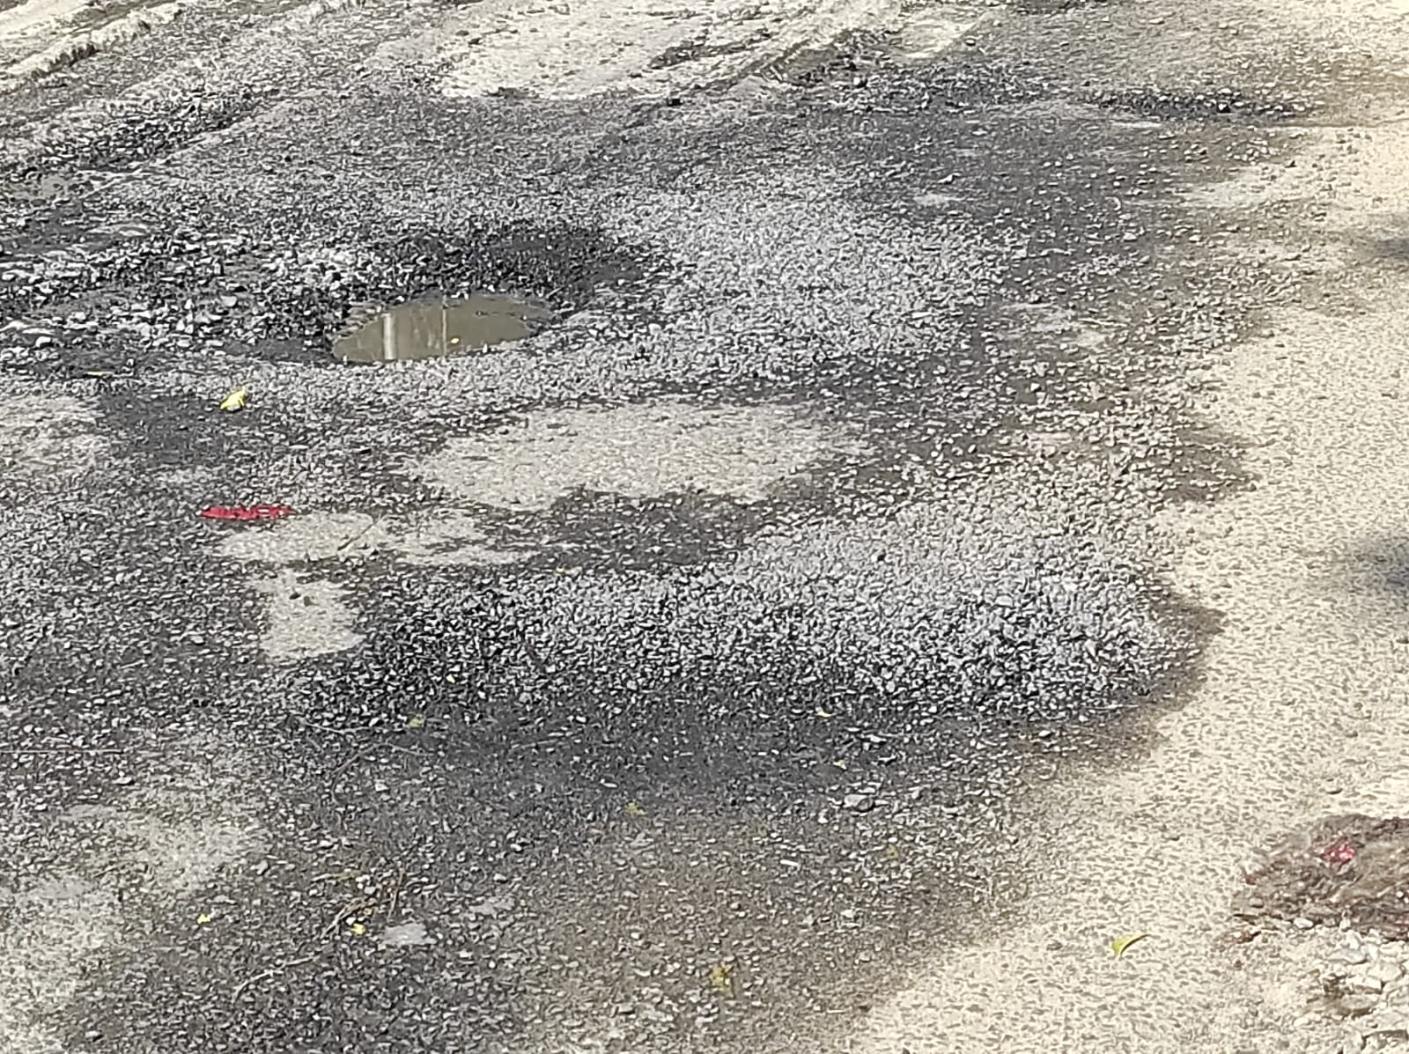

* Predicted Safety Speed: 8.442804336547852 Km/h

Poor road

Image: Test_image_48.jpg

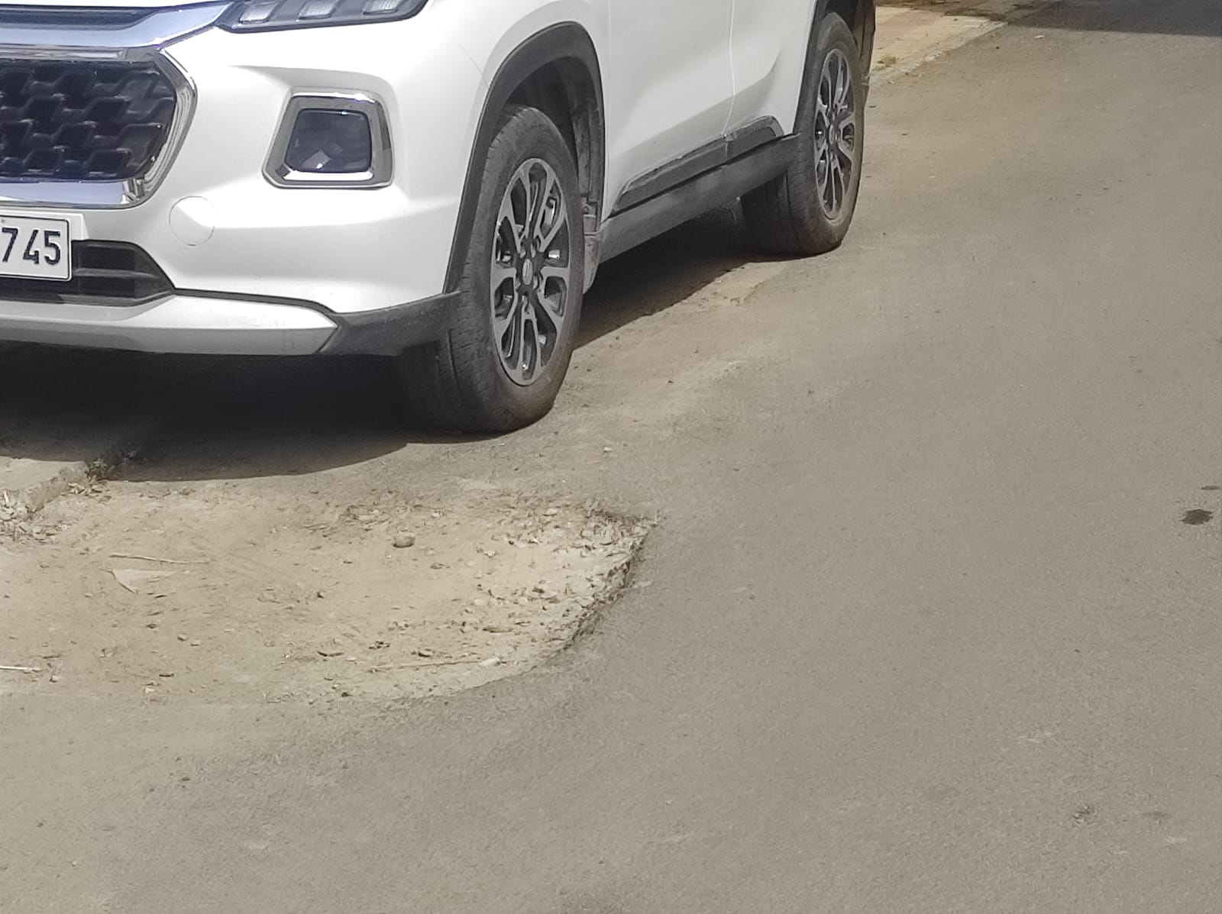

* Predicted Safety Speed: 8.59593677520752 Km/h

Poor road

Image: Test_image_13.jpg

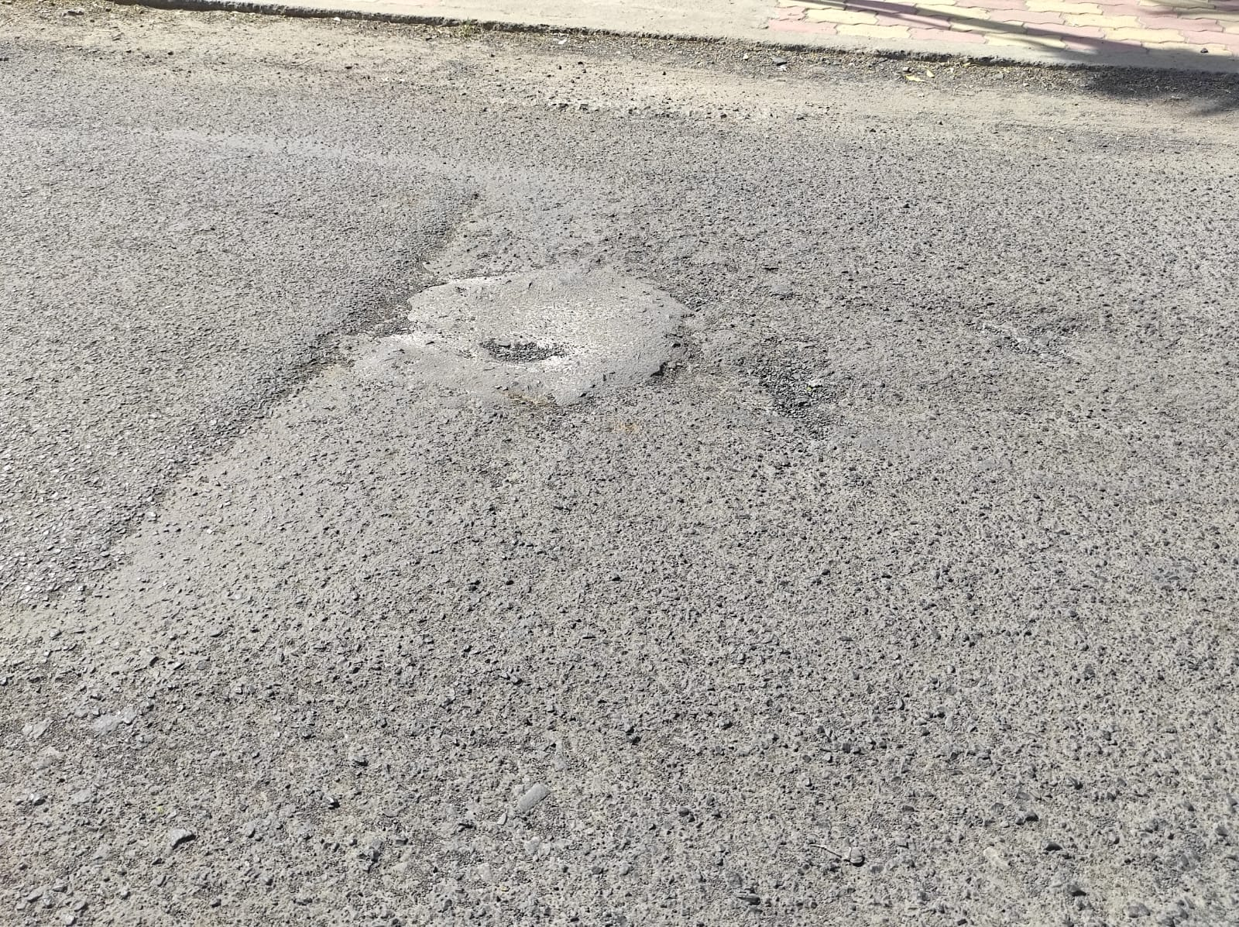

* Predicted Safety Speed: 8.639339447021484 Km/h

Poor road

Image: Test_image_20.jpg

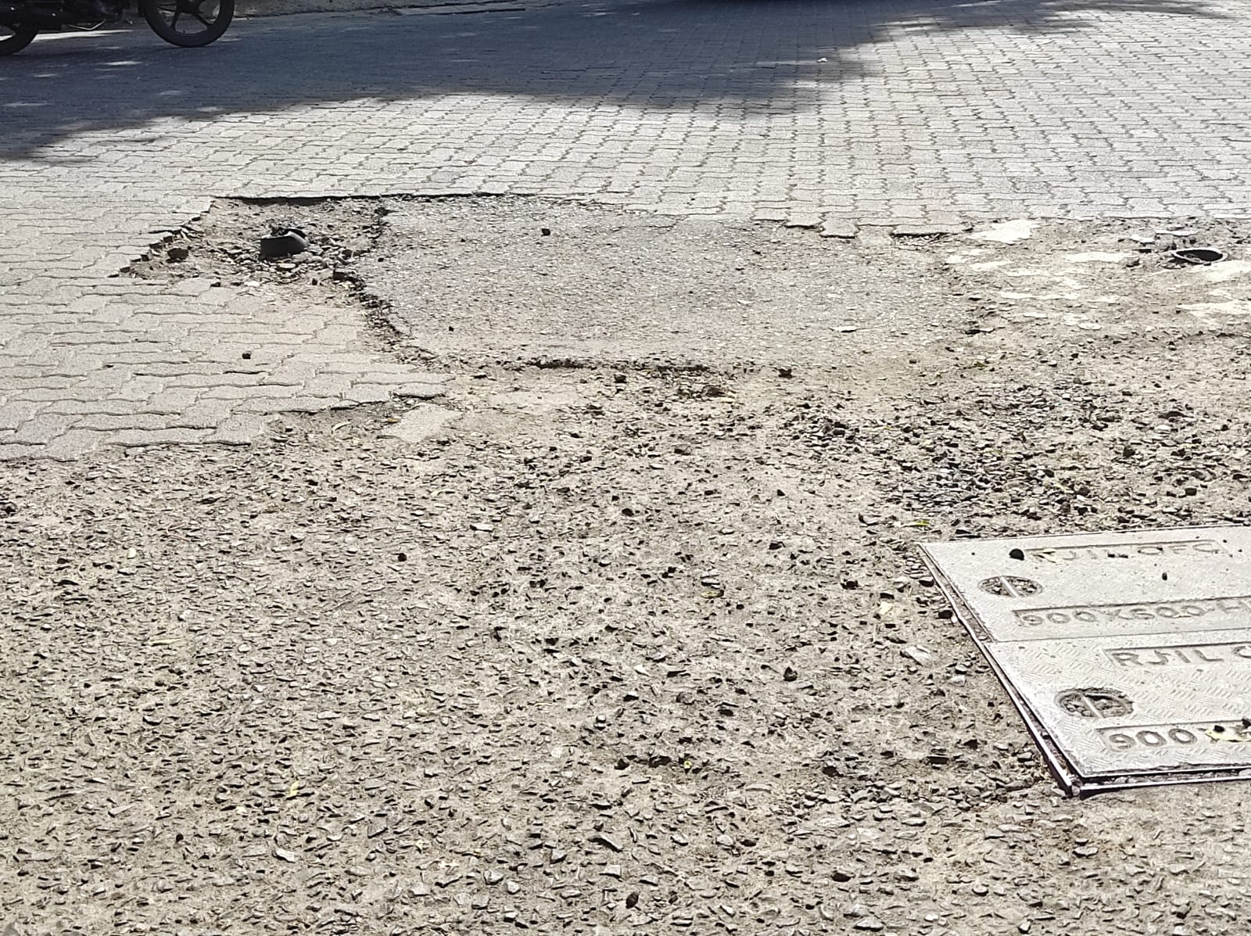

* Predicted Safety Speed: 8.824006080627441 Km/h

Poor road

Image: Test_image_60.jpg

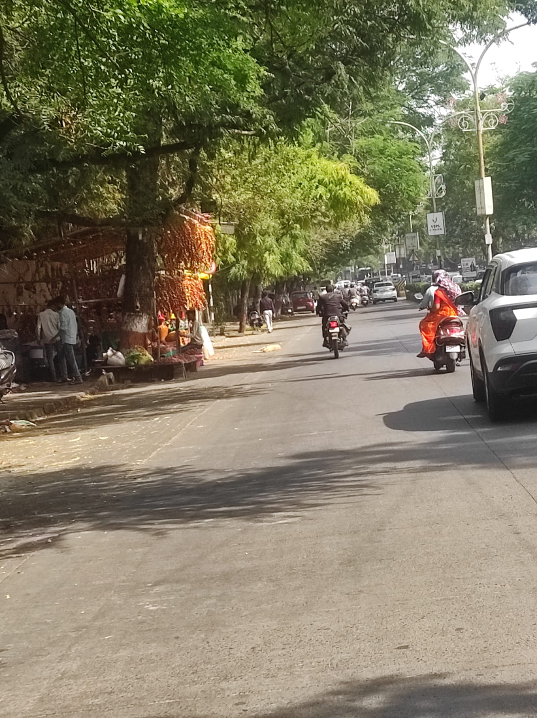

* Predicted Safety Speed: 9.01955509185791 Km/h

Poor road

Image: Test_image_58.jpg

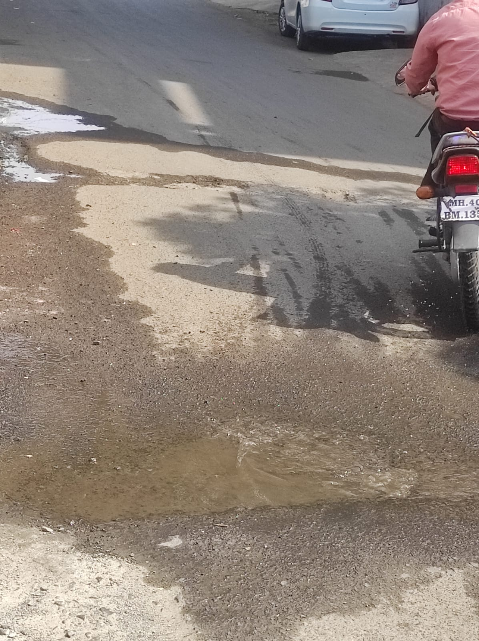

* Predicted Safety Speed: 9.046926498413086 Km/h

Poor road

Image: Test_image_5.jpg

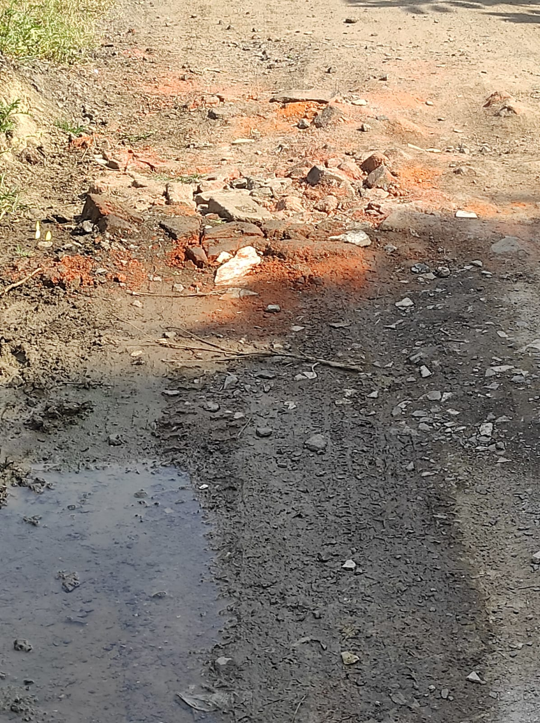

* Predicted Safety Speed: 9.090956687927246 Km/h

Poor road

Image: Test_image_42.jpg



* Predicted Safety Speed: 9.265810012817383 Km/h

Poor road

Image: Test_image_52.jpg

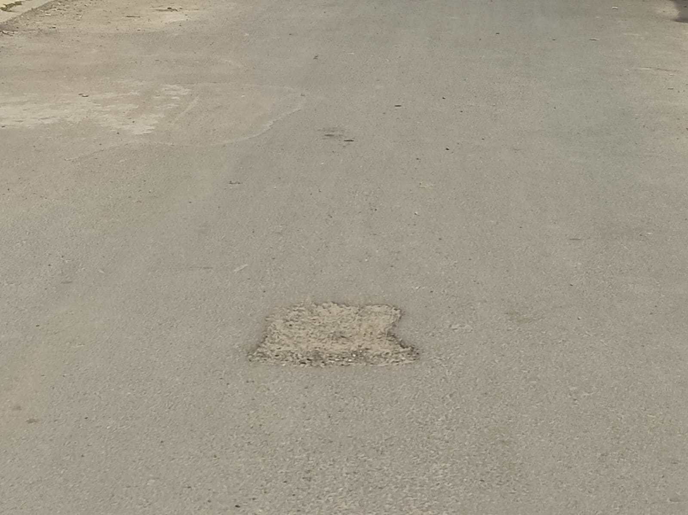

* Predicted Safety Speed: 9.464646339416504 Km/h

Poor road

Image: Test_image_32.jpg

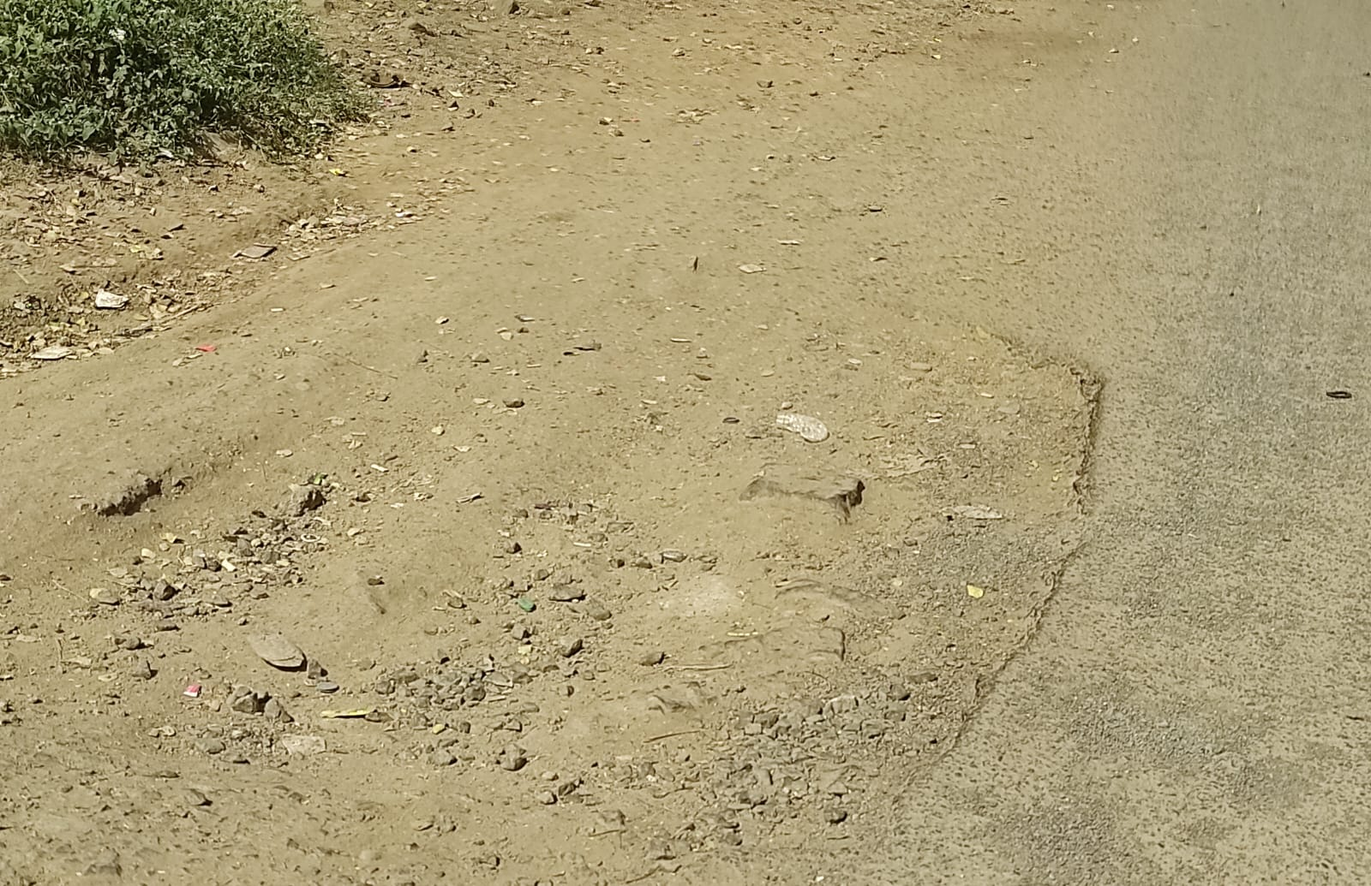

* Predicted Safety Speed: 9.496883392333984 Km/h

Poor road

Image: Test_image_69.jpeg

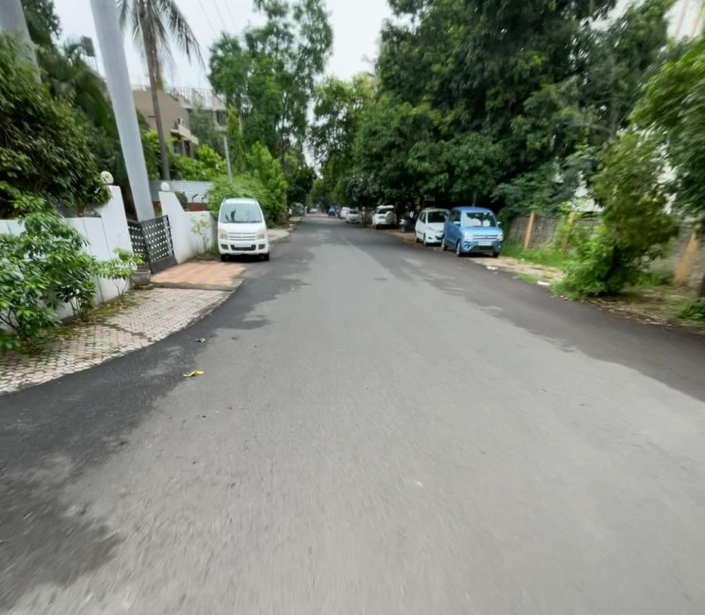

* Predicted Safety Speed: 9.526973724365234 Km/h

Poor road

Image: Test_image_38.jpg

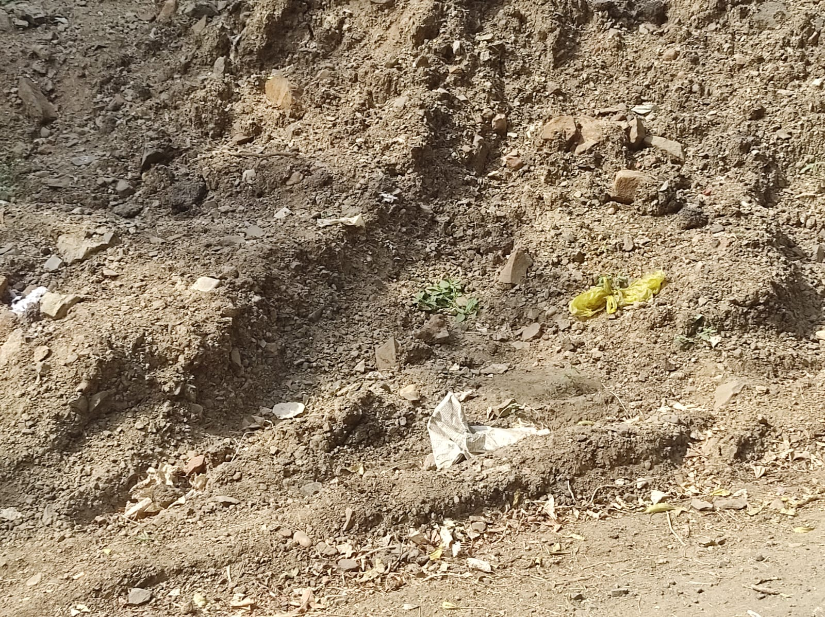

* Predicted Safety Speed: 9.626388549804688 Km/h

Poor road

Image: Test_image_49.jpg

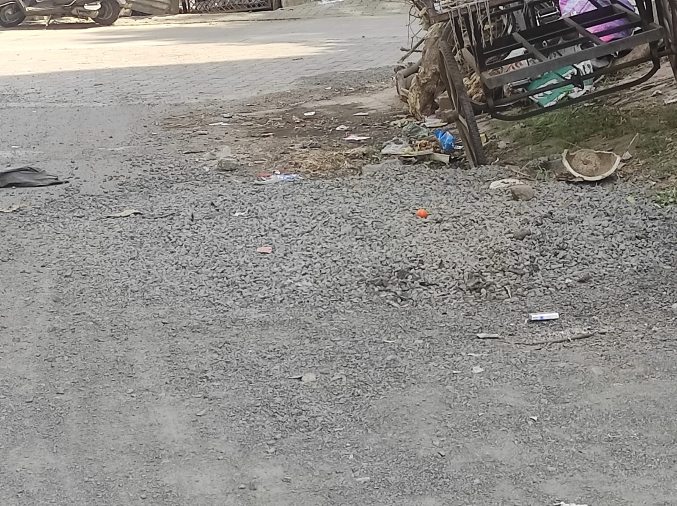

* Predicted Safety Speed: 9.829988479614258 Km/h

Poor road

Image: Test_image_56.jpg

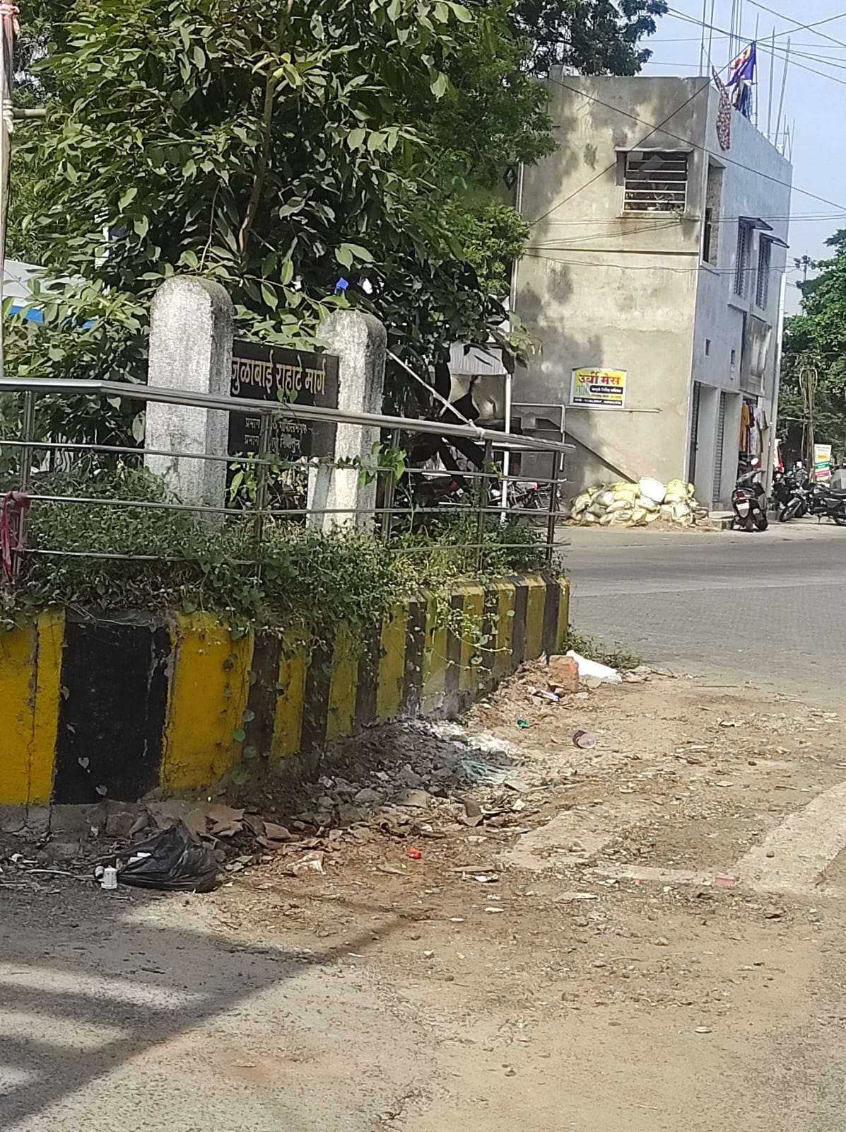

* Predicted Safety Speed: 9.918392181396484 Km/h

Poor road

# Images in the Category: 10 Km/h - 20 Km/h

Image: Test_image_72.jpeg

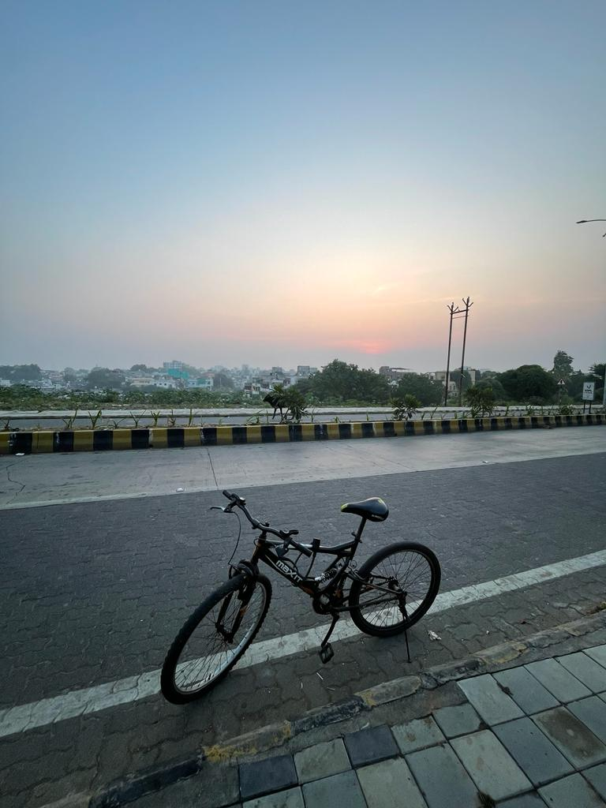

* Predicted Safety Speed: 10.146164894104004 Km/h

Poor road

Image: Test_image_63.jpg

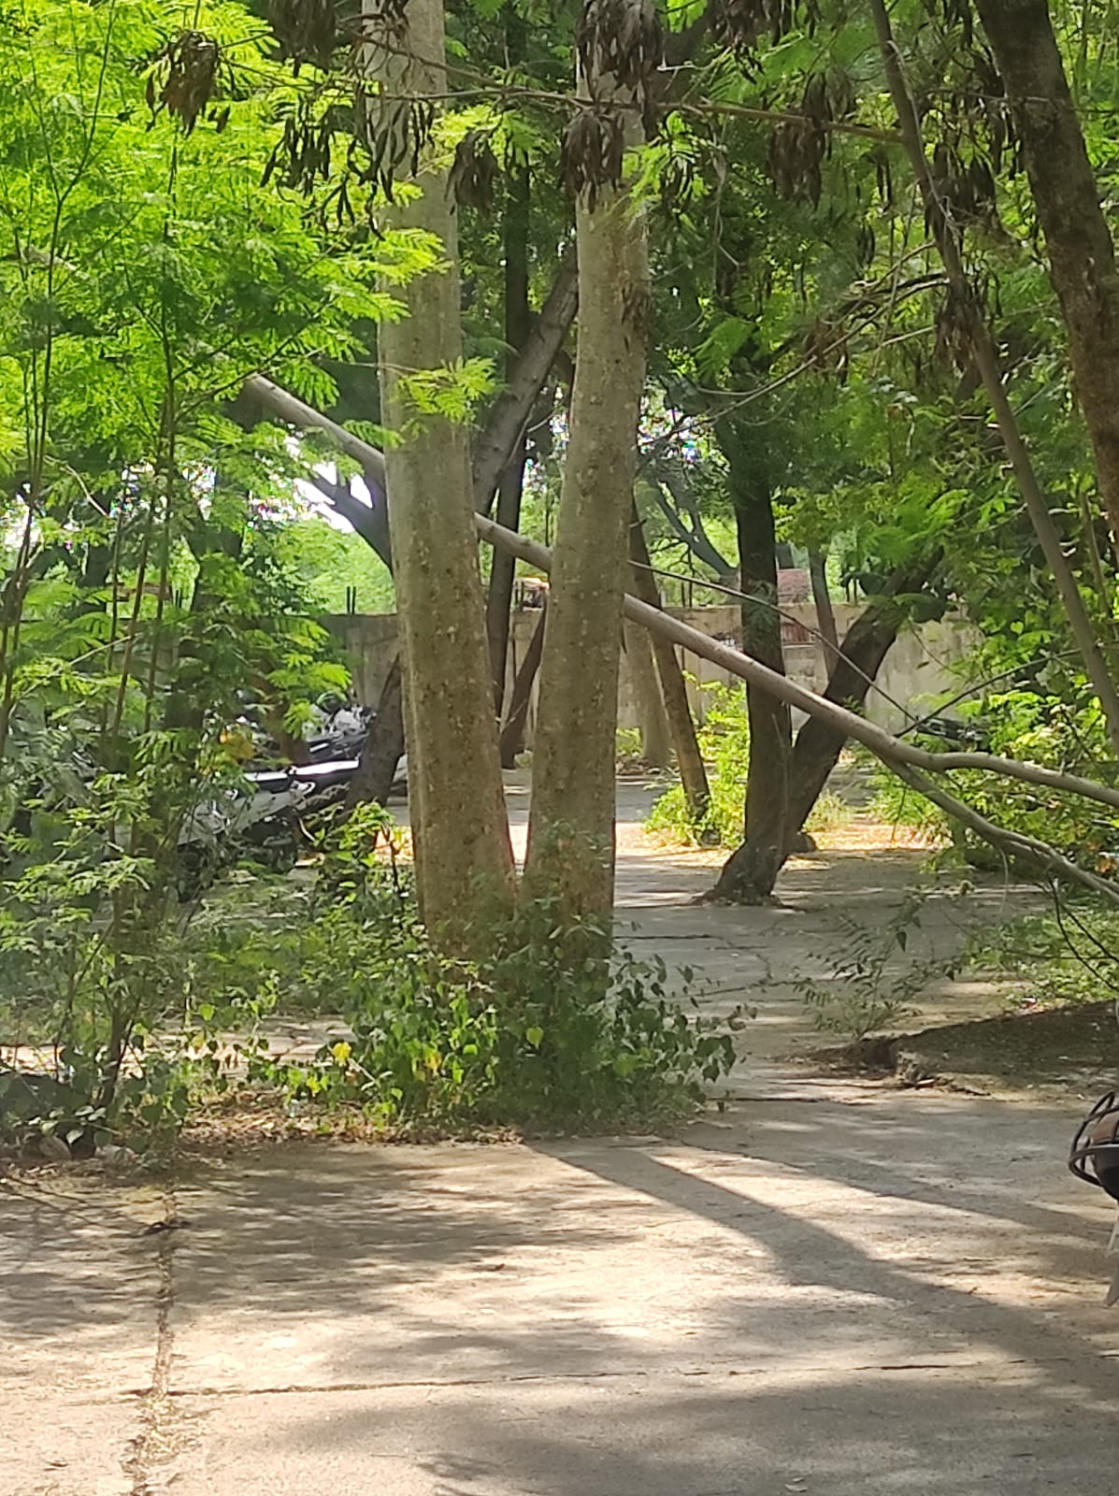

* Predicted Safety Speed: 10.217445373535156 Km/h

Poor road

Image: Test_image_65.jpg

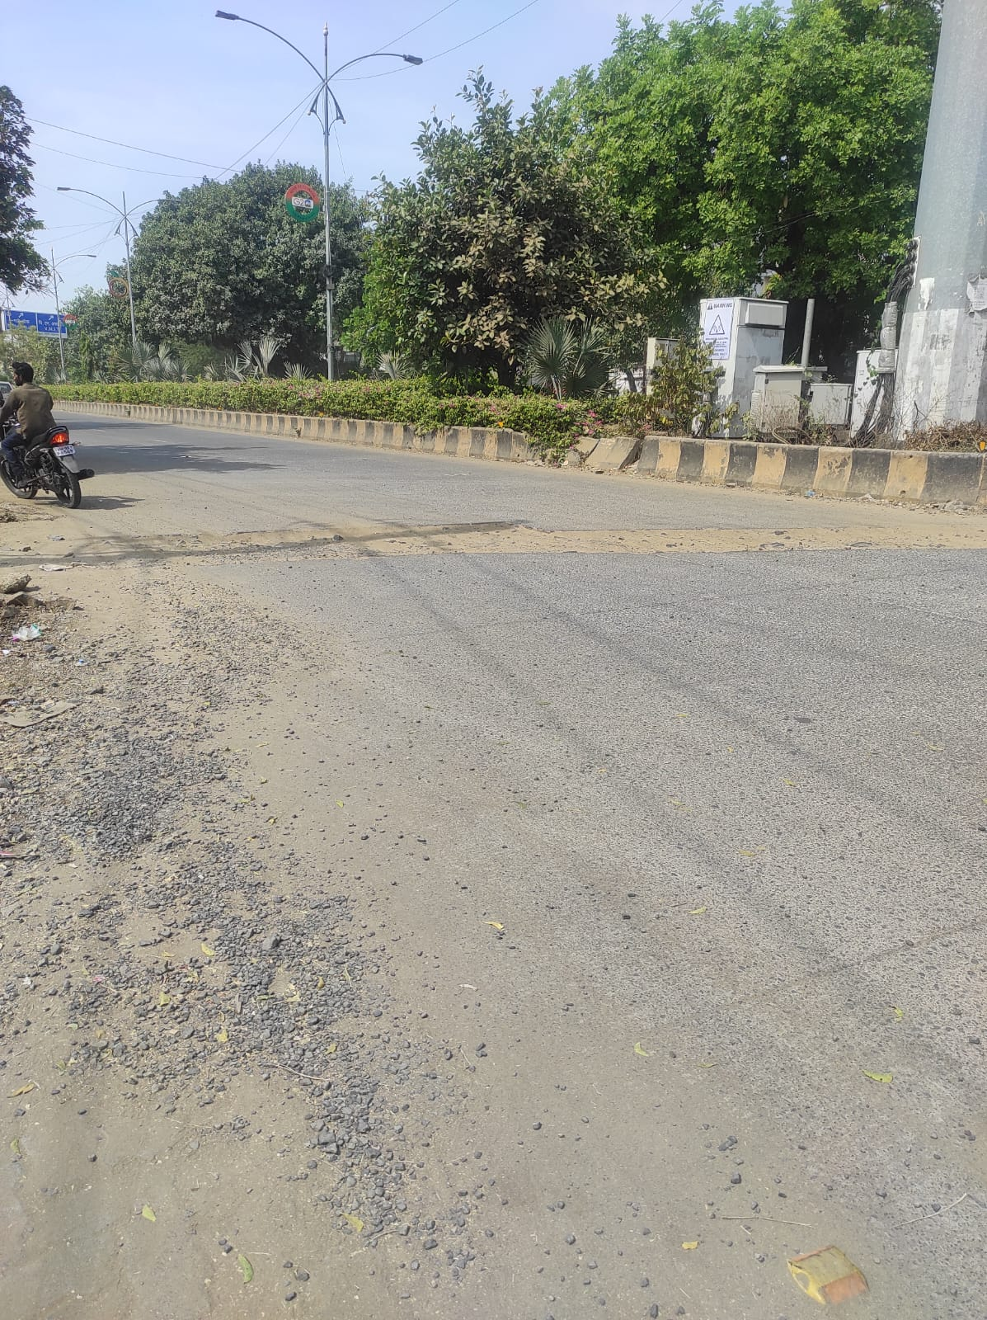

* Predicted Safety Speed: 10.427164077758789 Km/h

Poor road

Image: Test_image_66.jpg

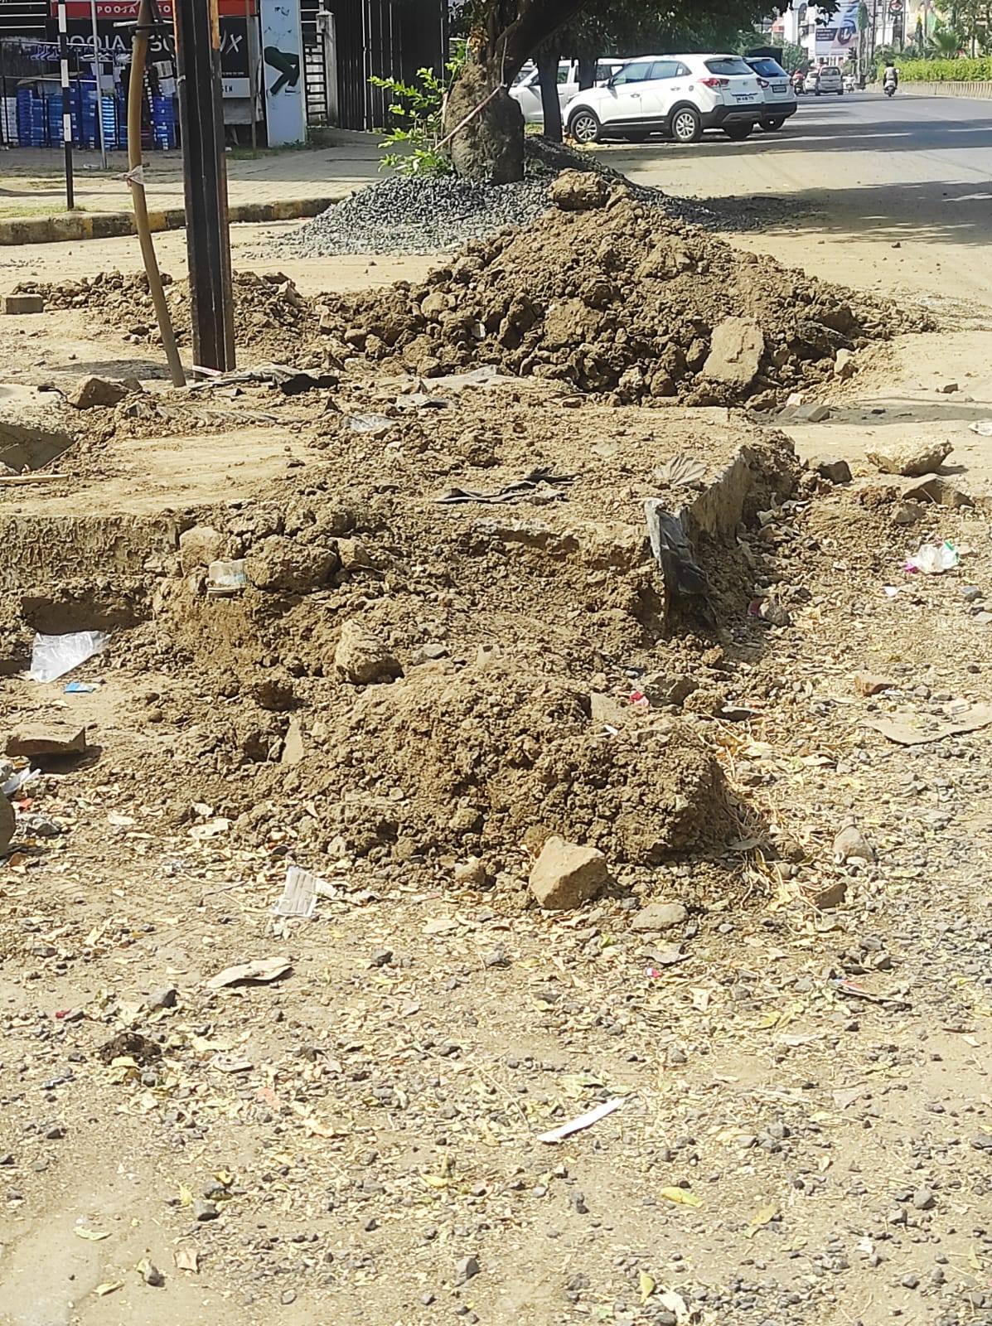

* Predicted Safety Speed: 10.539475440979004 Km/h

Poor road

Image: Test_image_6.jpg

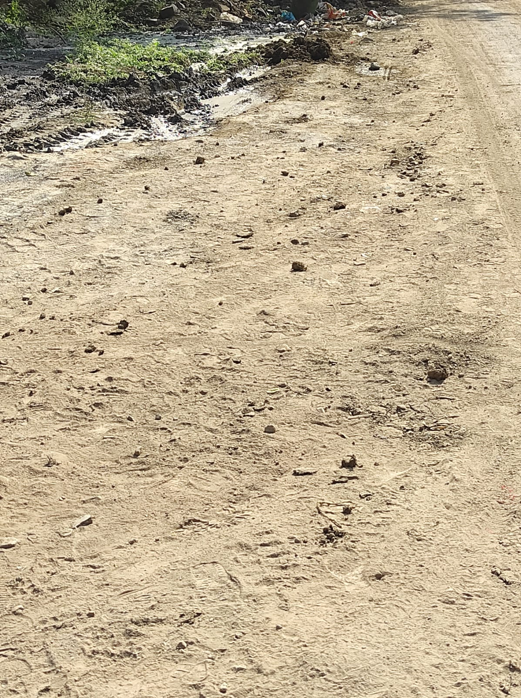

* Predicted Safety Speed: 10.652641296386719 Km/h

Poor road

Image: Test_image_71.jpeg

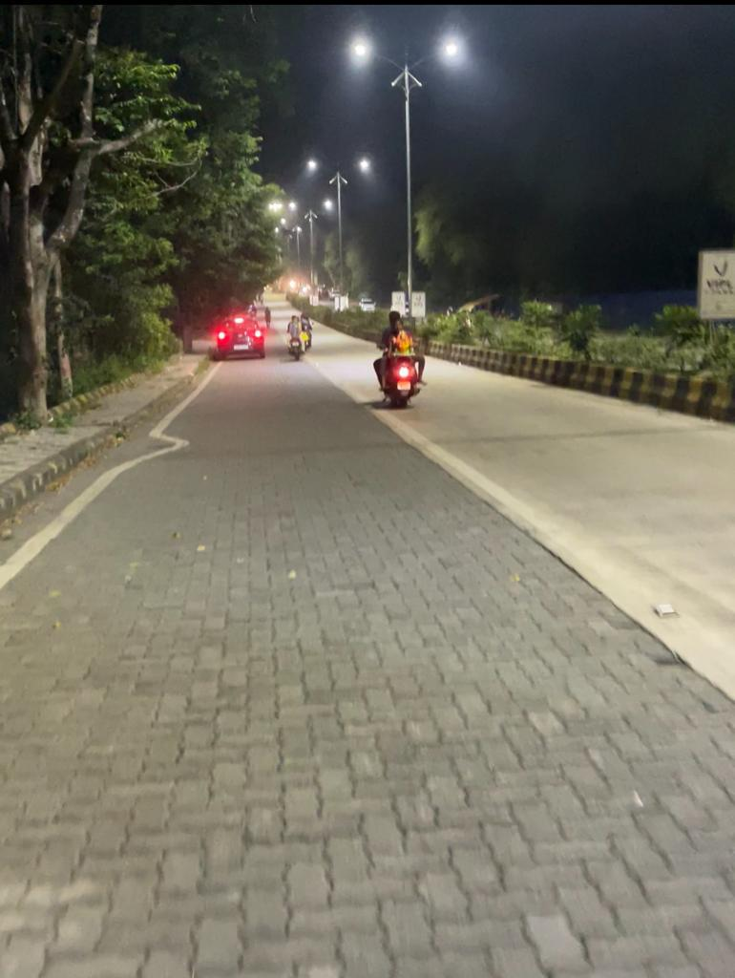

* Predicted Safety Speed: 10.653939247131348 Km/h

Poor road

Image: Test_image_73.jpeg

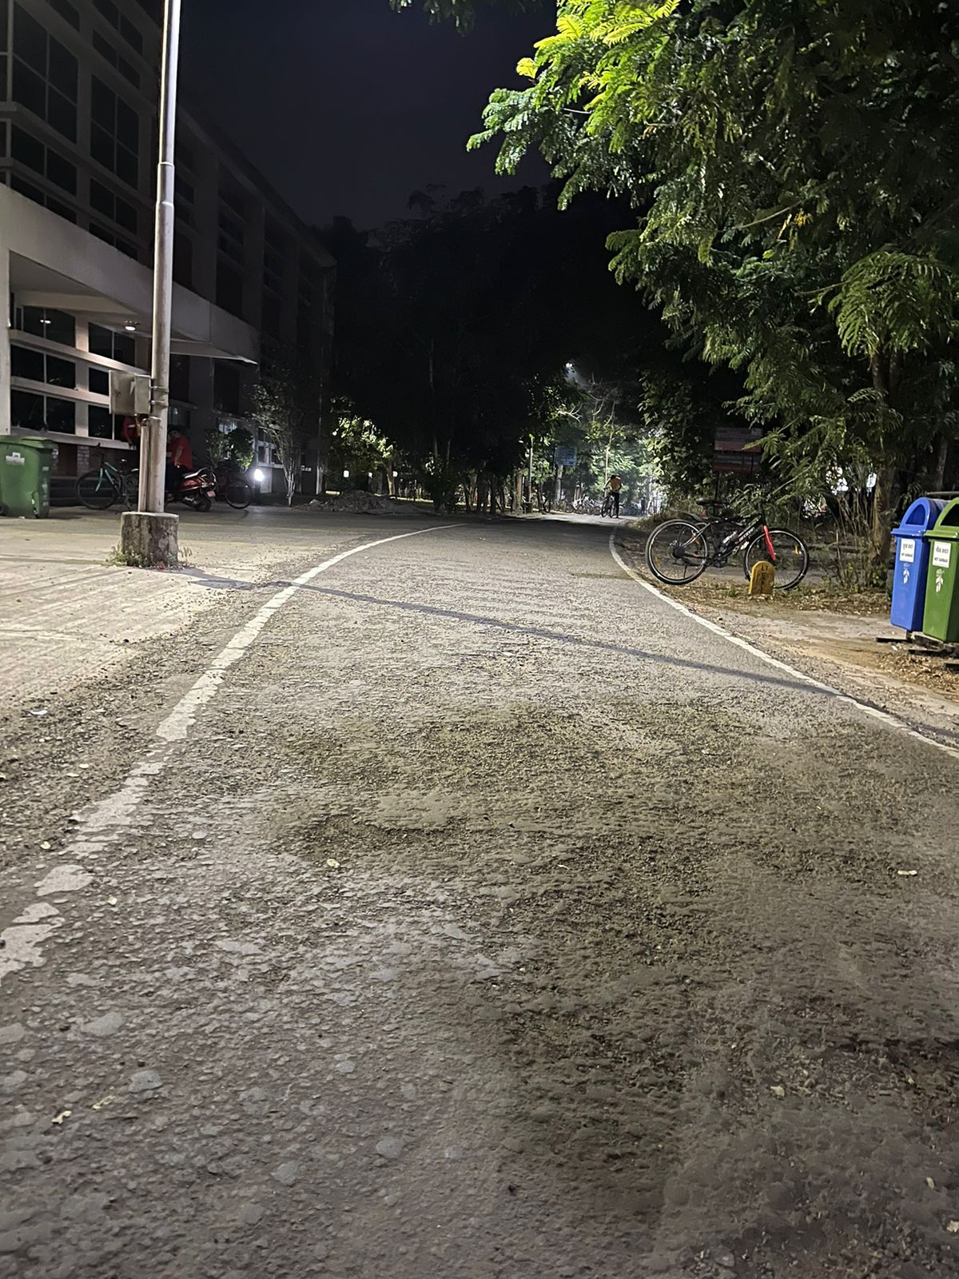

* Predicted Safety Speed: 10.833077430725098 Km/h

Poor road

Image: Test_image_76.jpg

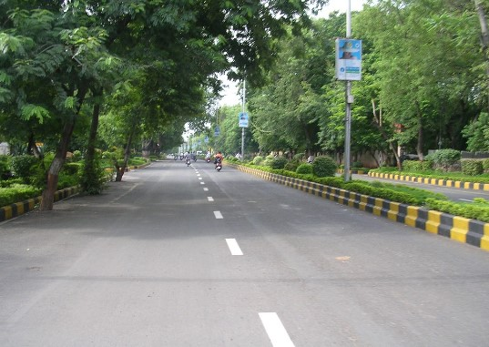

* Predicted Safety Speed: 11.110918045043945 Km/h

Poor road

Image: Test_image_62.jpg

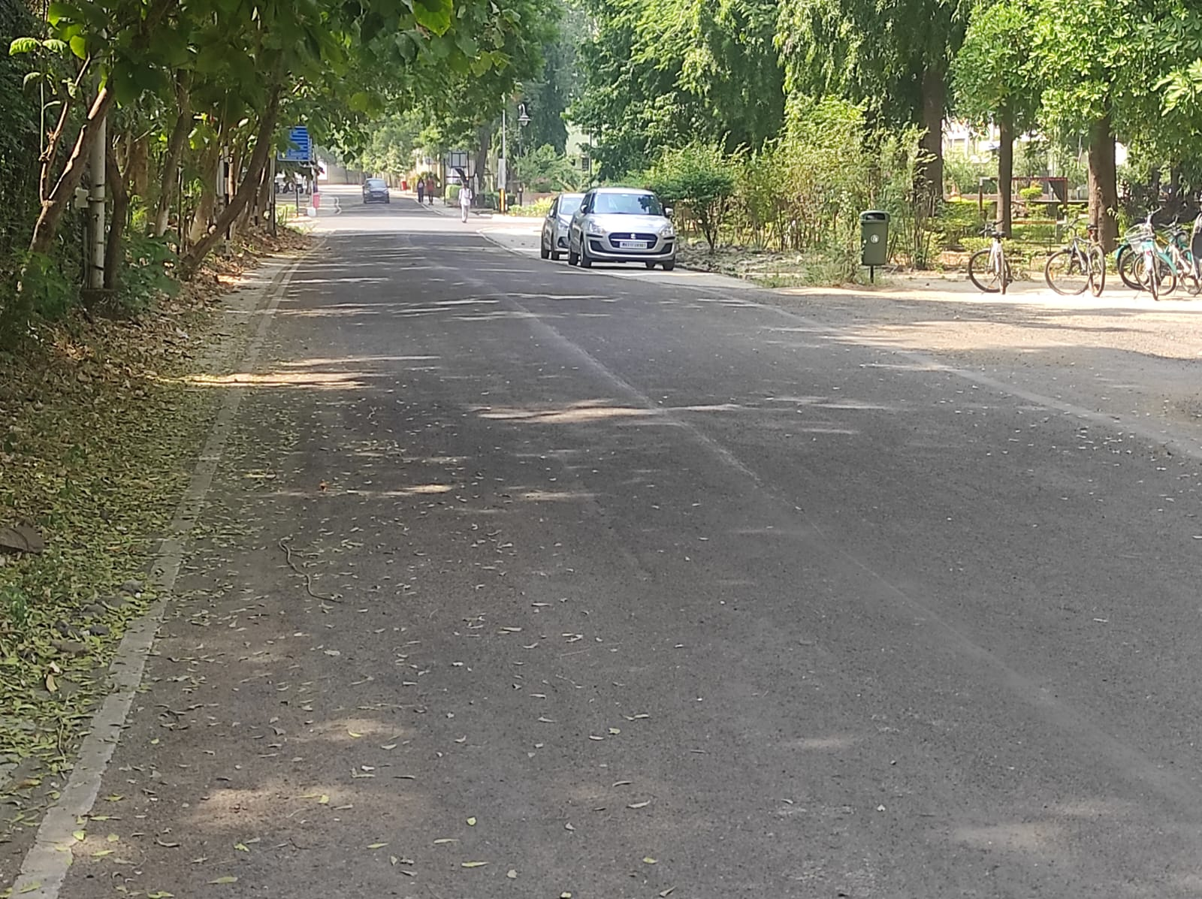

* Predicted Safety Speed: 11.167401313781738 Km/h

Poor road

Image: Test_image_11.jpg

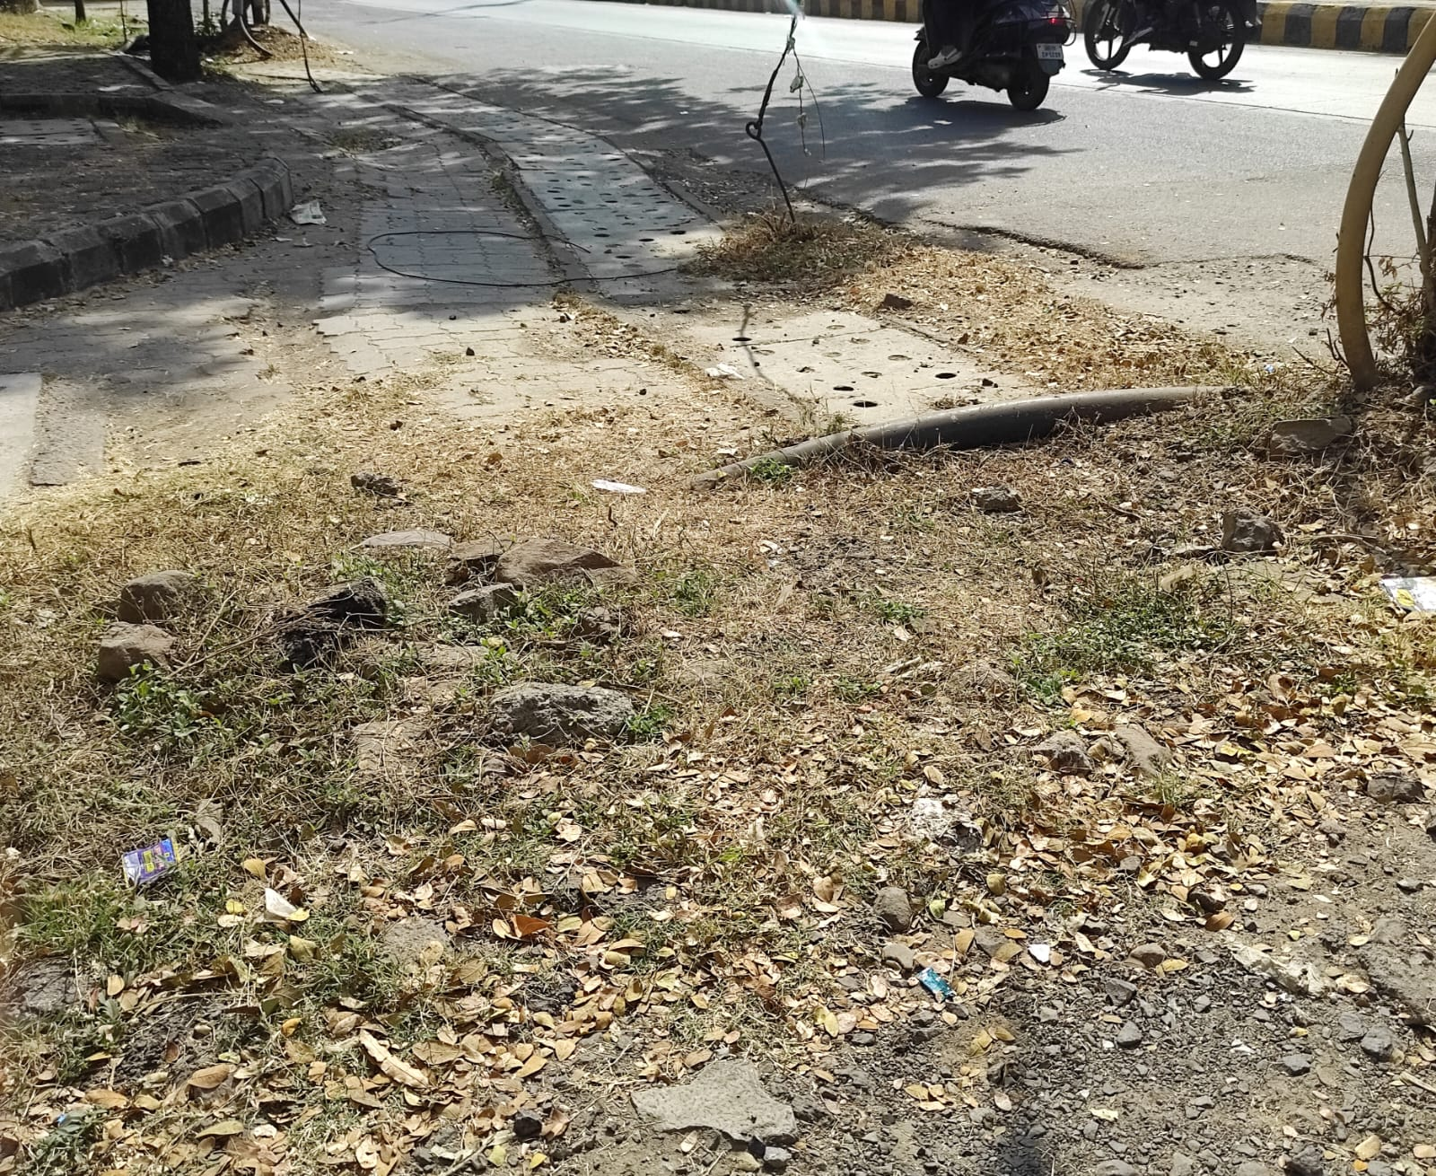

* Predicted Safety Speed: 11.244237899780273 Km/h

Poor road

Image: Test_image_54.jpg

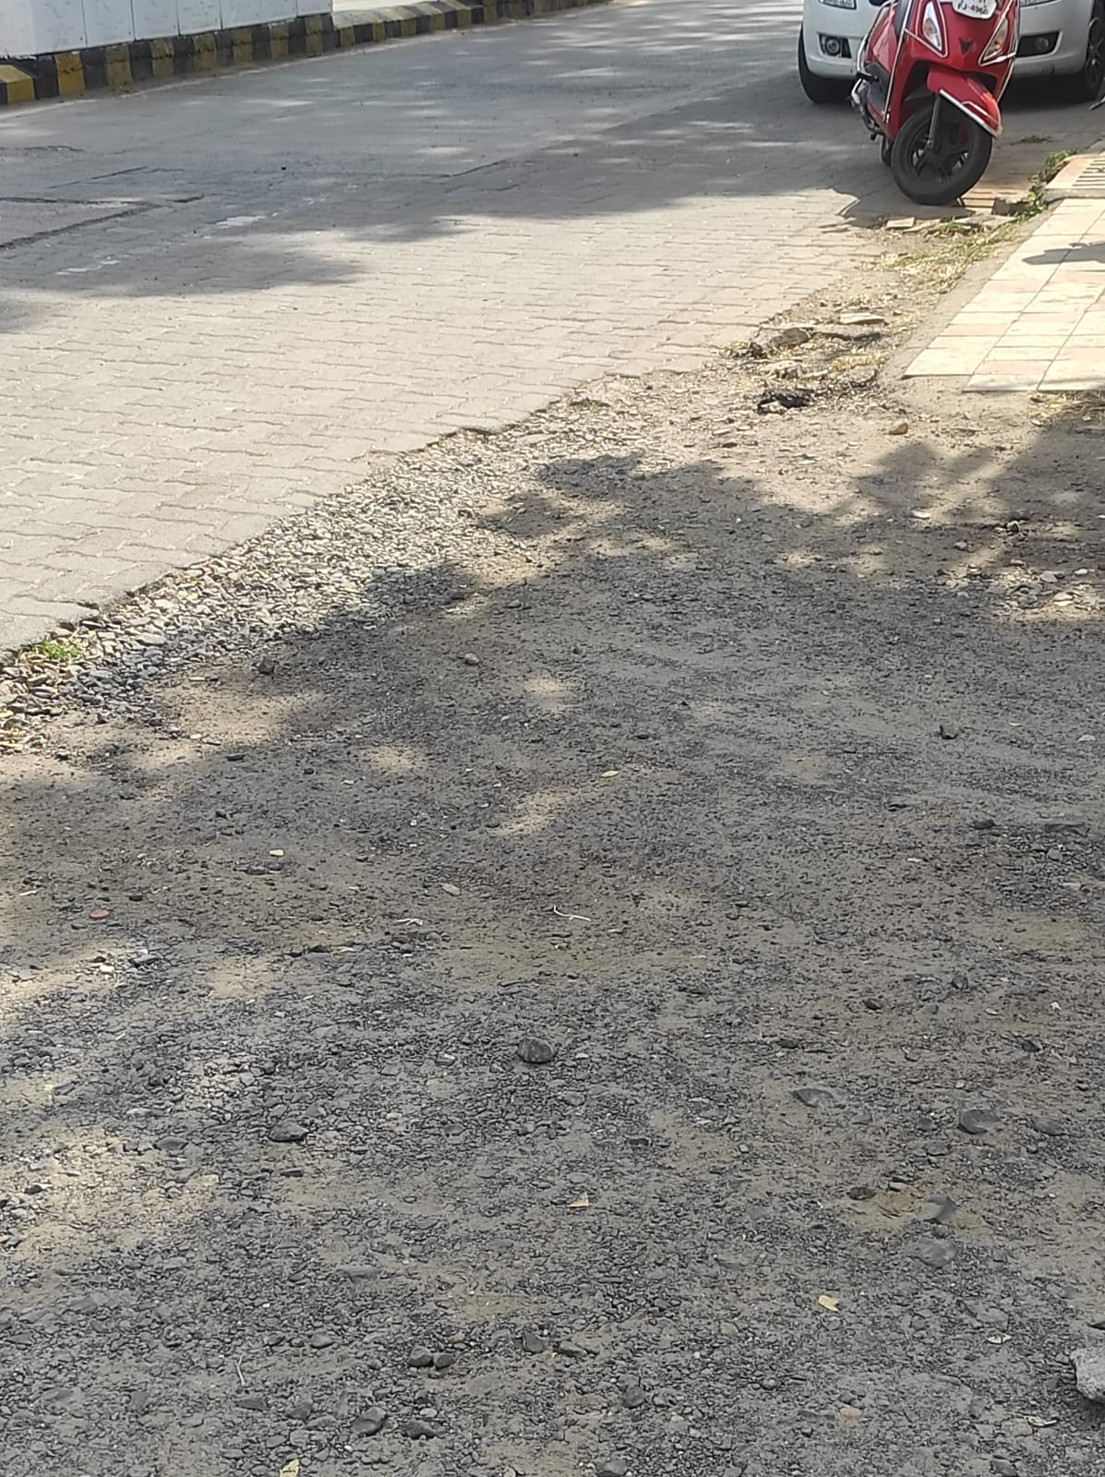

* Predicted Safety Speed: 11.249566078186035 Km/h

Poor road

Image: Test_image_18.jpg

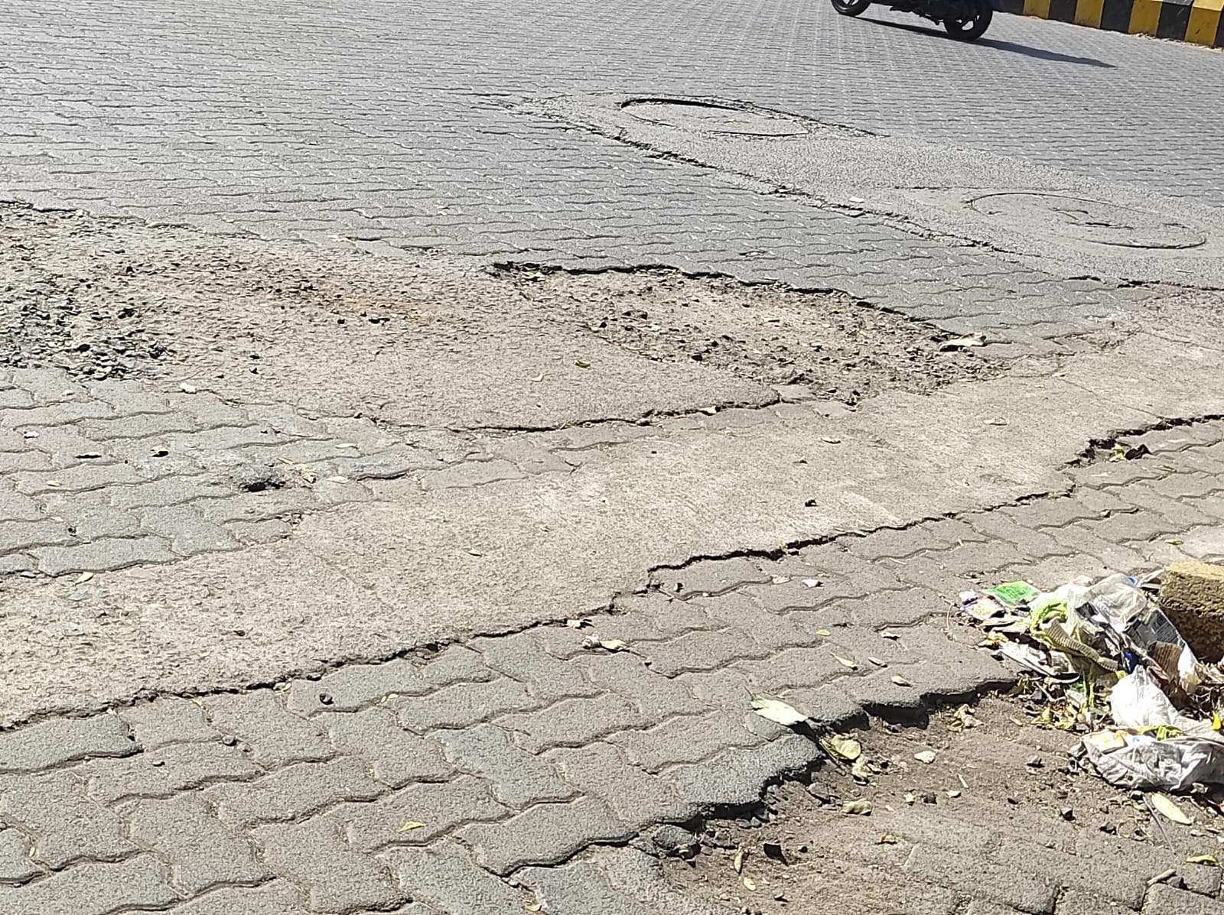

* Predicted Safety Speed: 12.09922981262207 Km/h

Poor road

Image: Test_image_75.jpeg

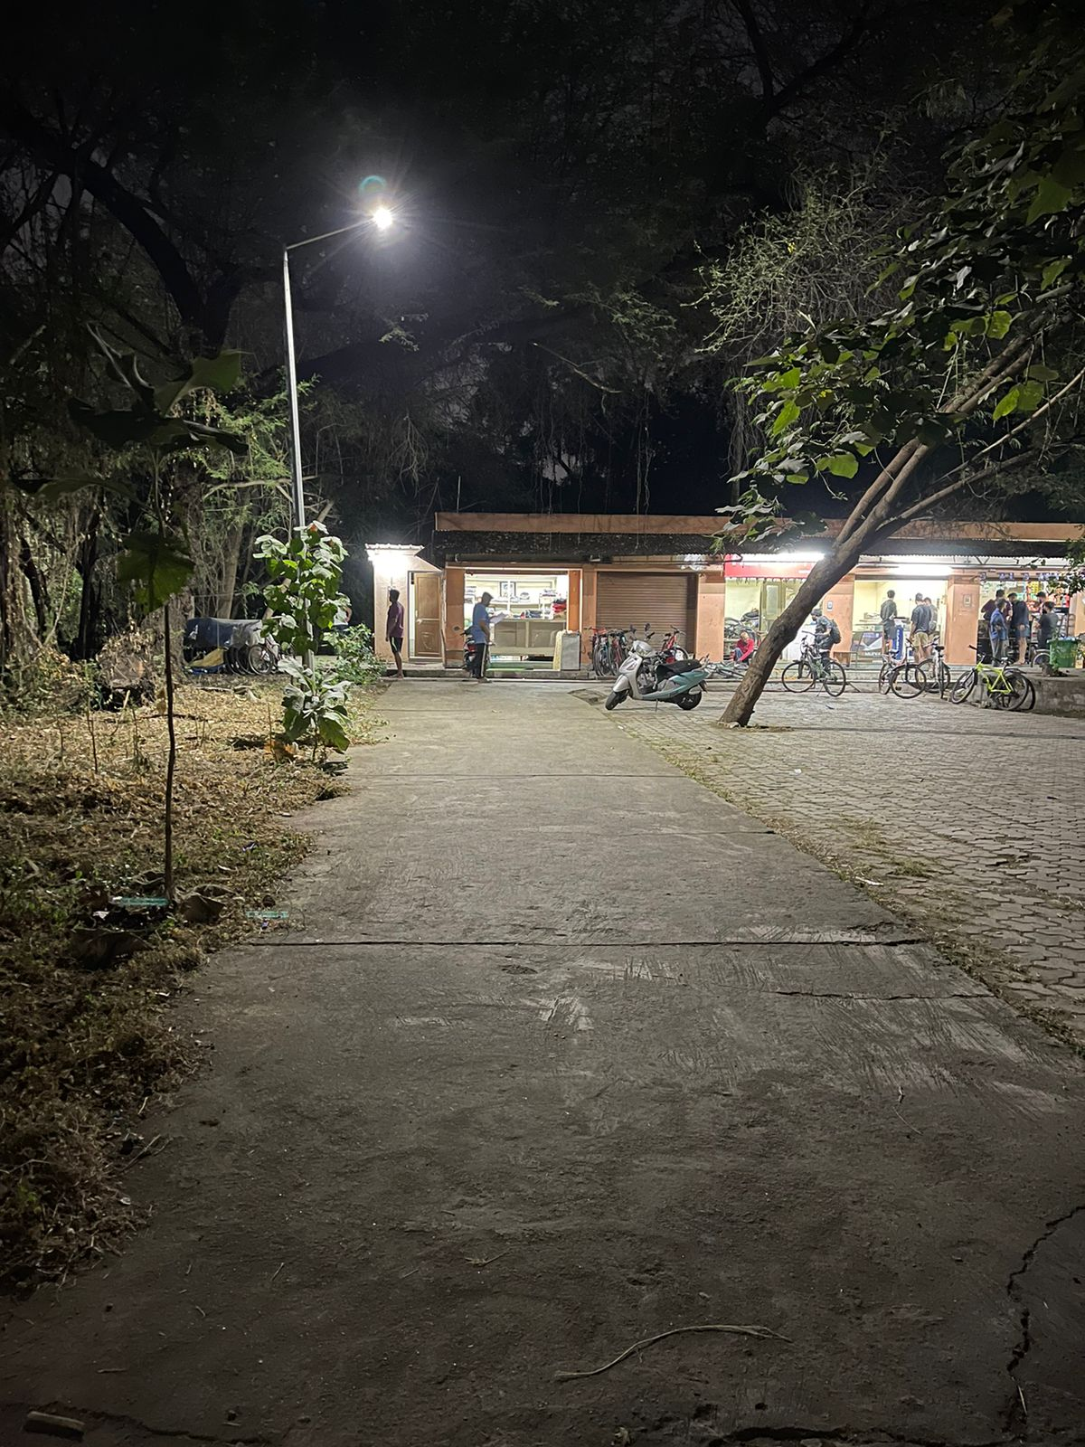

* Predicted Safety Speed: 12.256365776062012 Km/h

Poor road

Image: Test_image_17.jpg

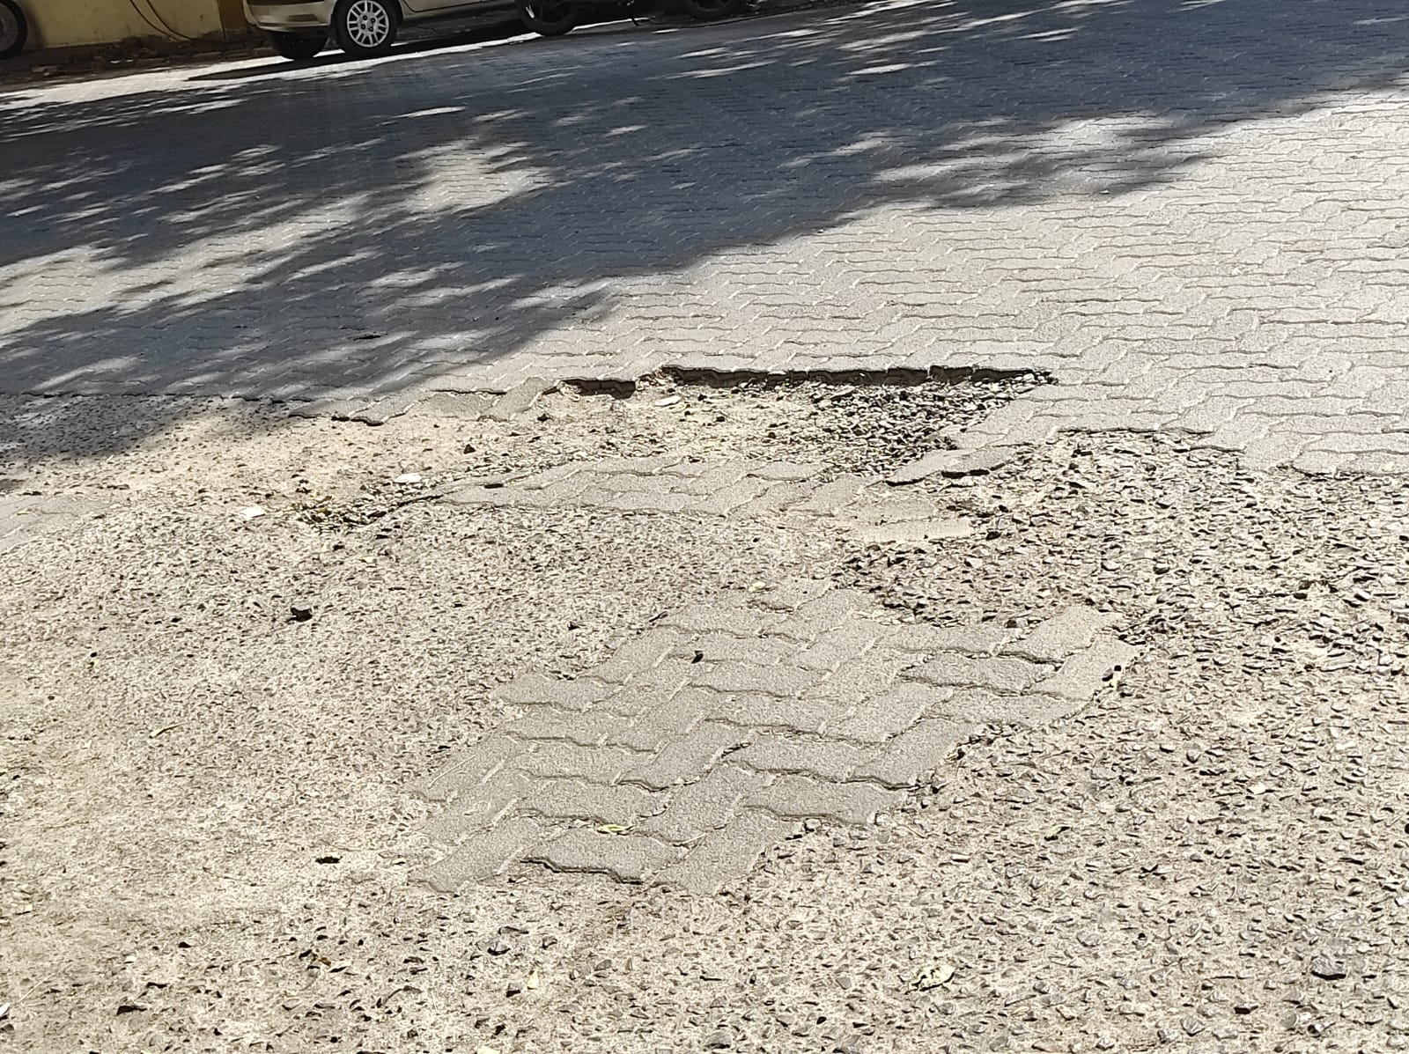

* Predicted Safety Speed: 12.341506958007812 Km/h

Poor road

Image: Test_image_67.jpg

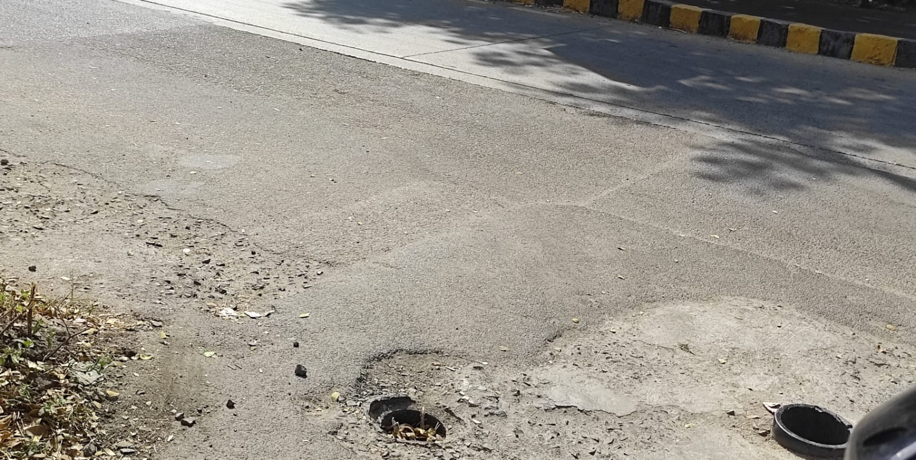

* Predicted Safety Speed: 12.368842124938965 Km/h

Poor road

Image: Test_image_1.jpg

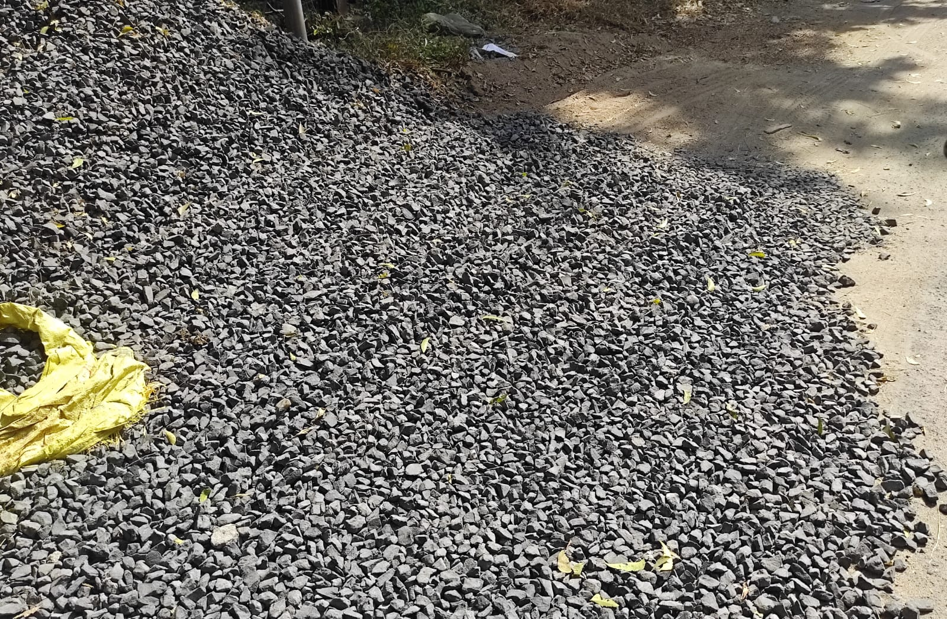

* Predicted Safety Speed: 12.732271194458008 Km/h

Poor road

Image: Test_image_12.jpg

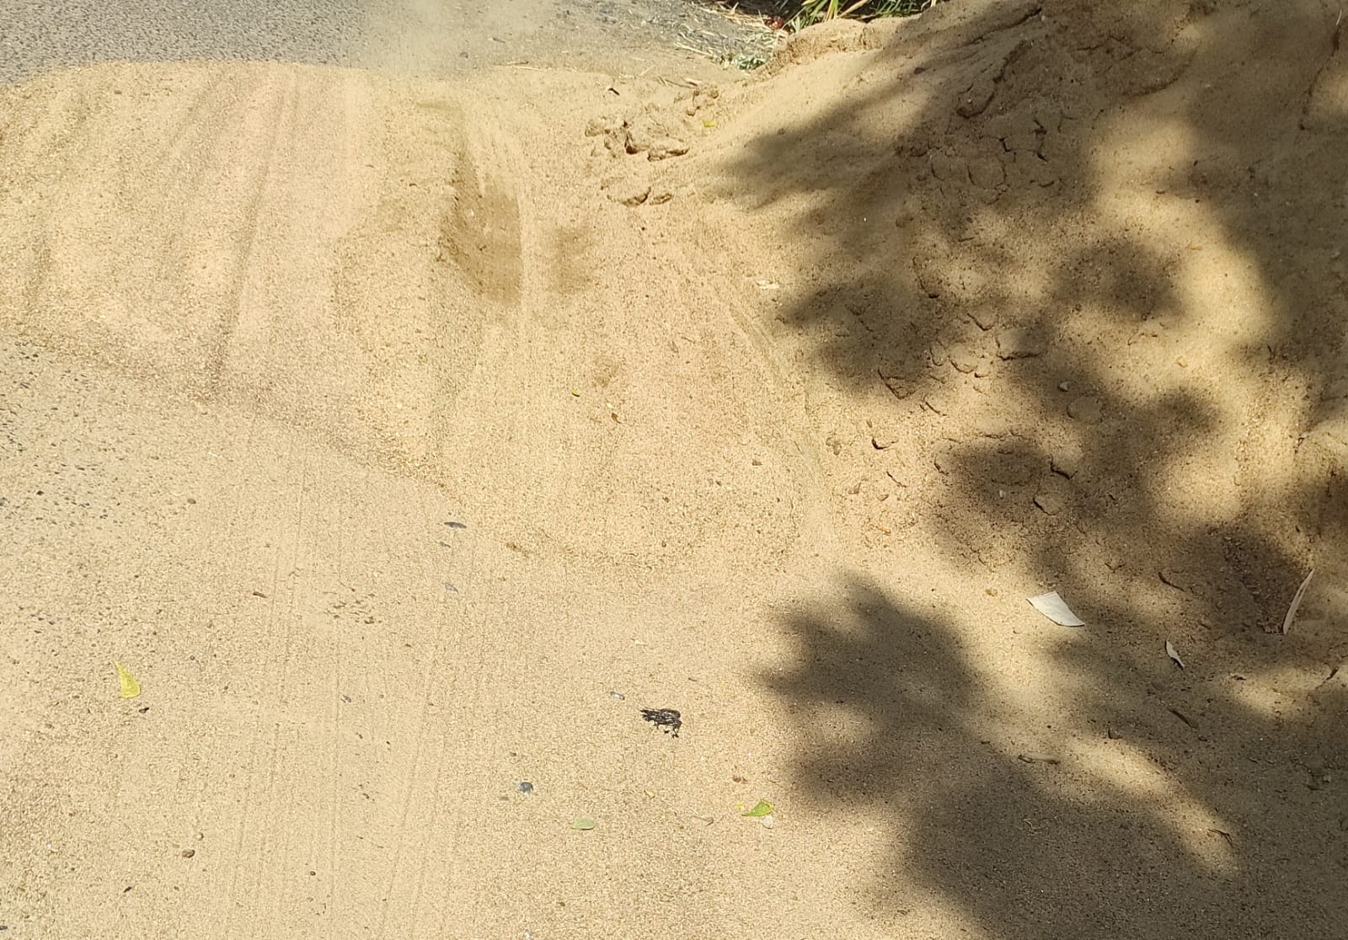

* Predicted Safety Speed: 12.912409782409668 Km/h

Poor road

Image: Test_image_74.jpeg

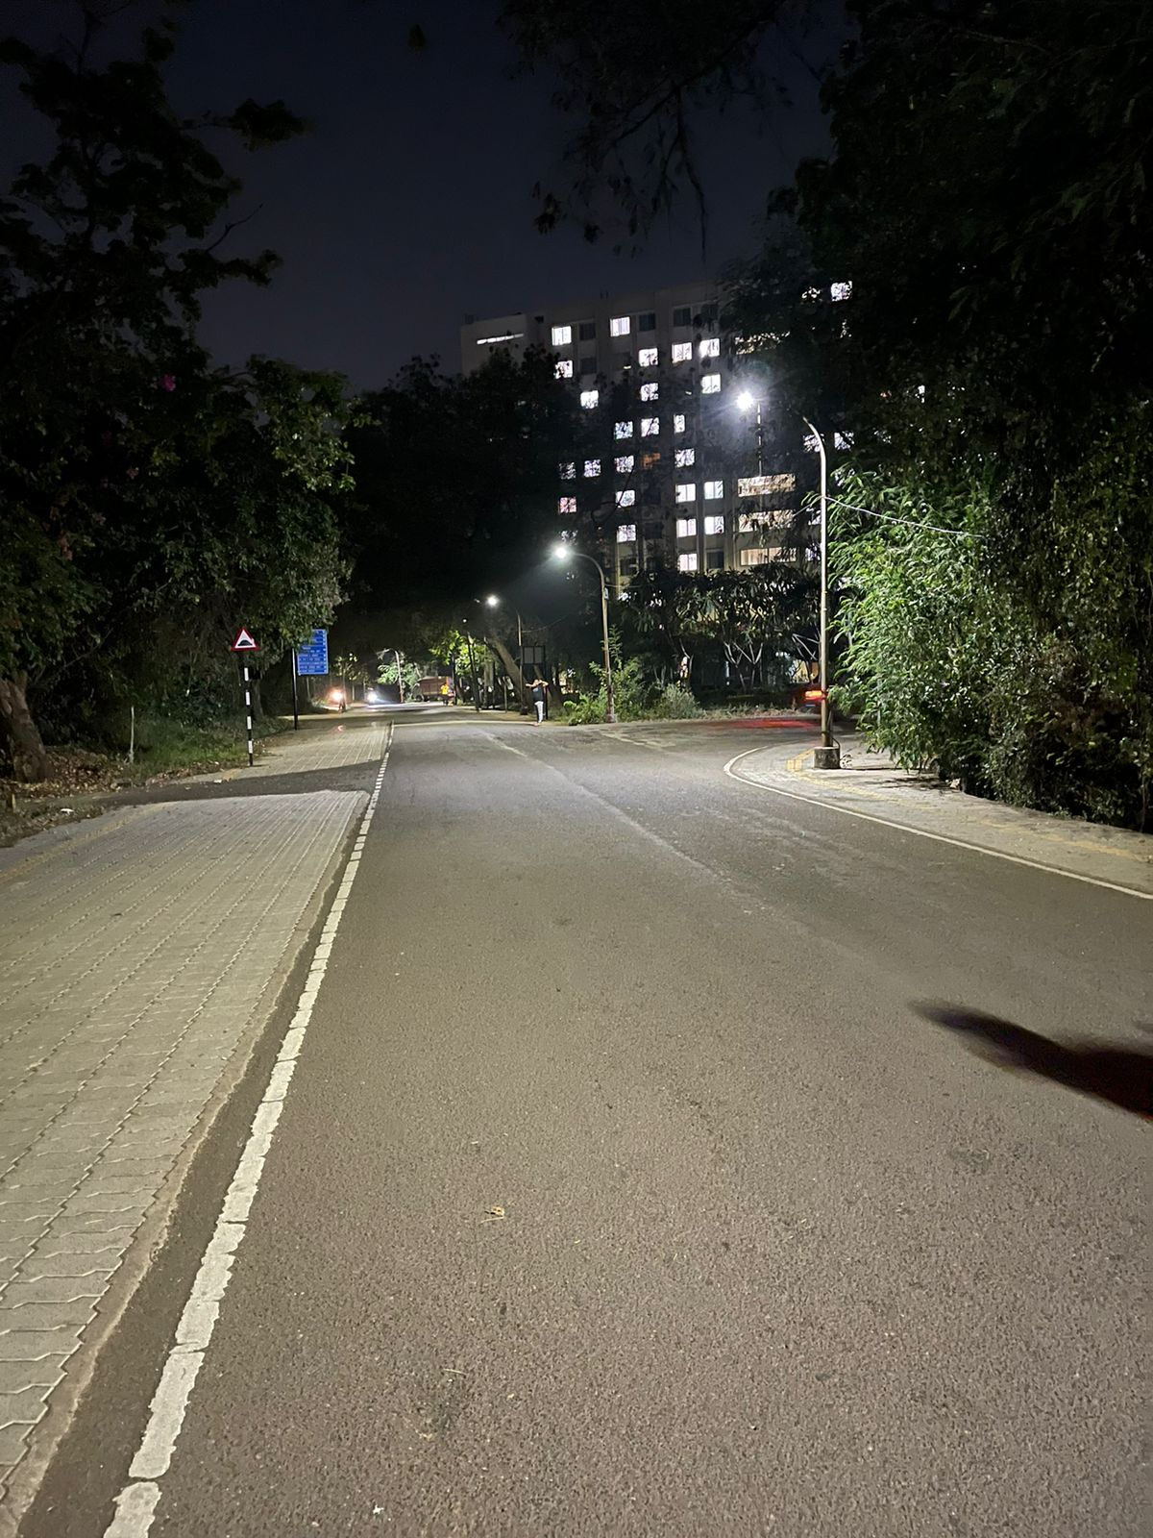

* Predicted Safety Speed: 14.966071128845215 Km/h

Good road

Image: Test_image_46.jpg

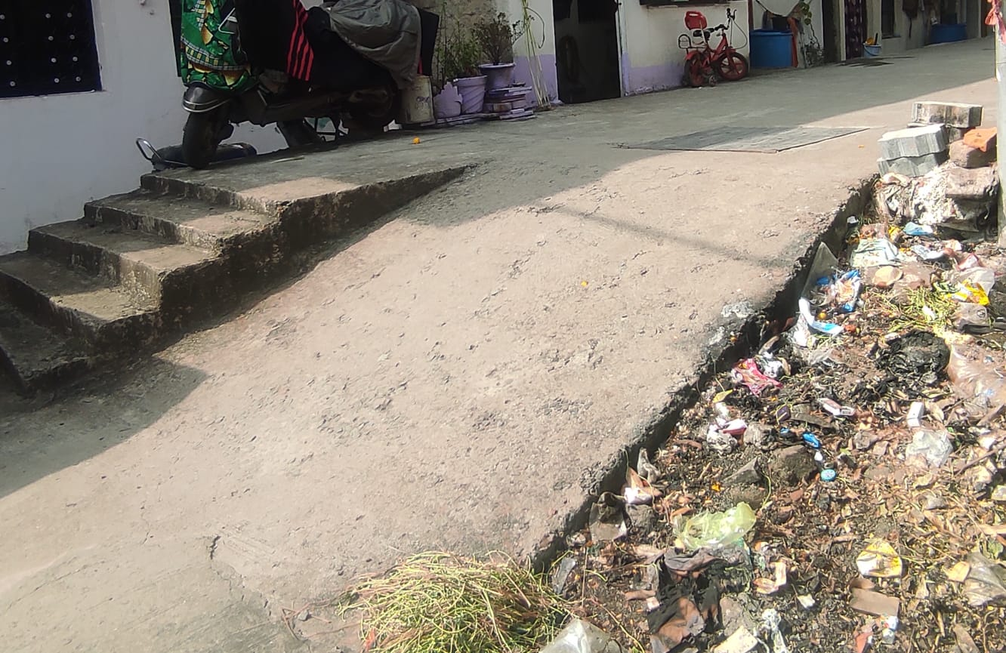

* Predicted Safety Speed: 15.261371612548828 Km/h

Good road

Image: Test_image_22.jpg

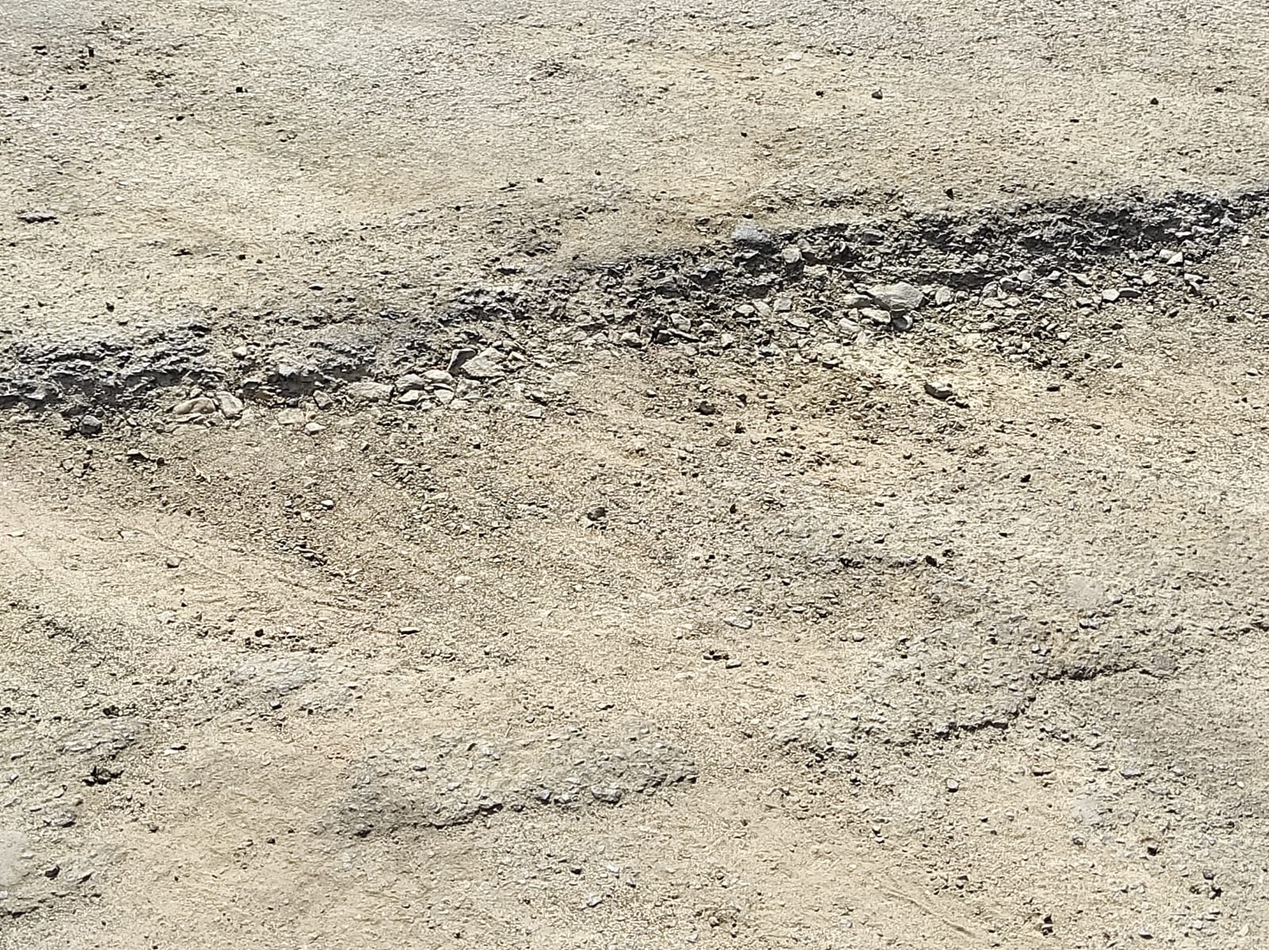

* Predicted Safety Speed: 15.461793899536133 Km/h

Good road

Image: Test_image_70.jpeg

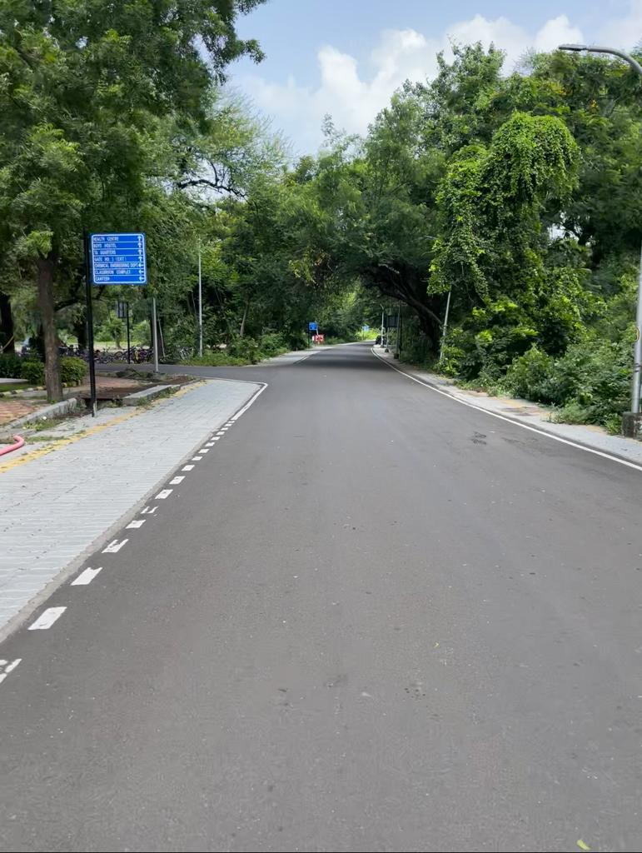

* Predicted Safety Speed: 15.7967529296875 Km/h

Good road

Image: Test_image_59.jpg

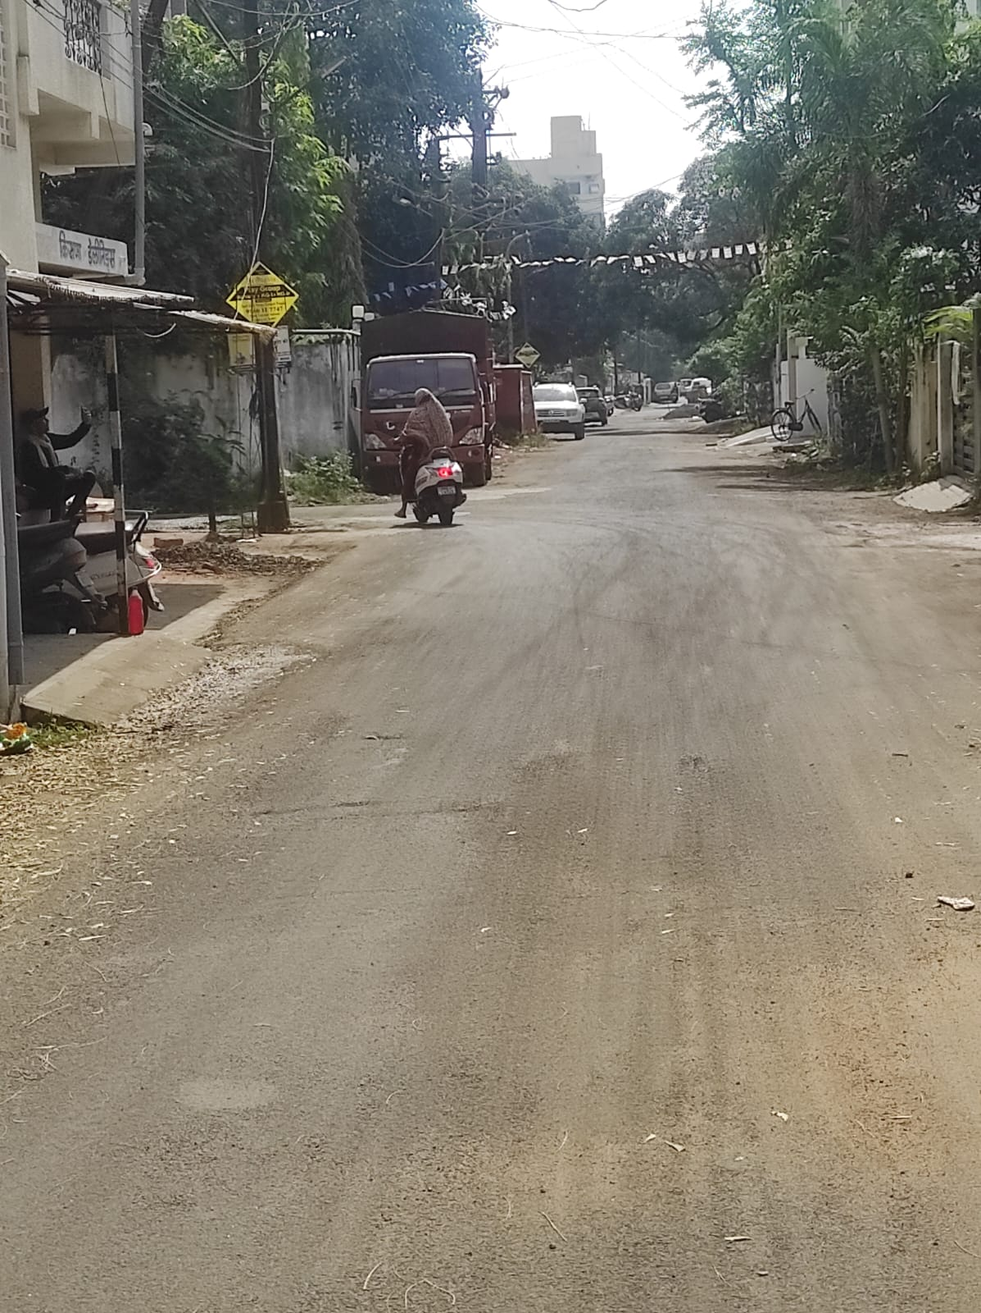

* Predicted Safety Speed: 17.082069396972656 Km/h

Good road

Image: Test_image_26.jpg

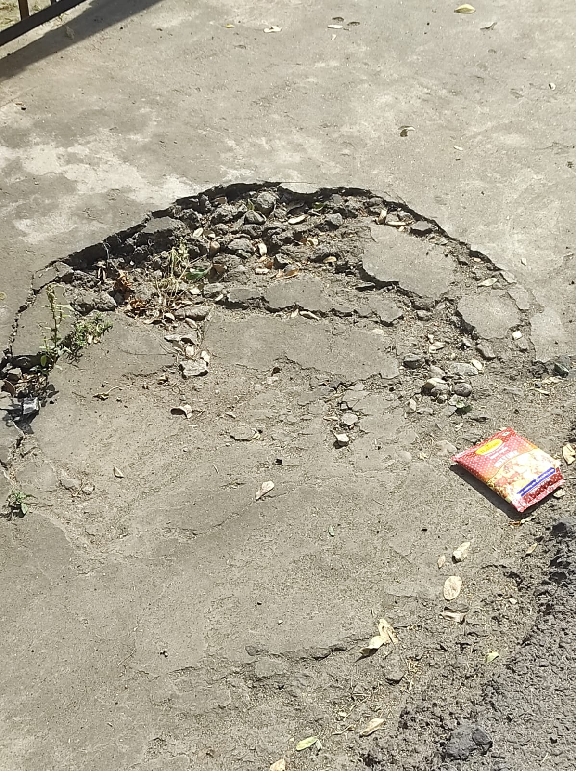

* Predicted Safety Speed: 19.00568962097168 Km/h

Good road

# Images in the Category: 20 Km/h - 40 Km/h

Image: Test_image_55.jpg

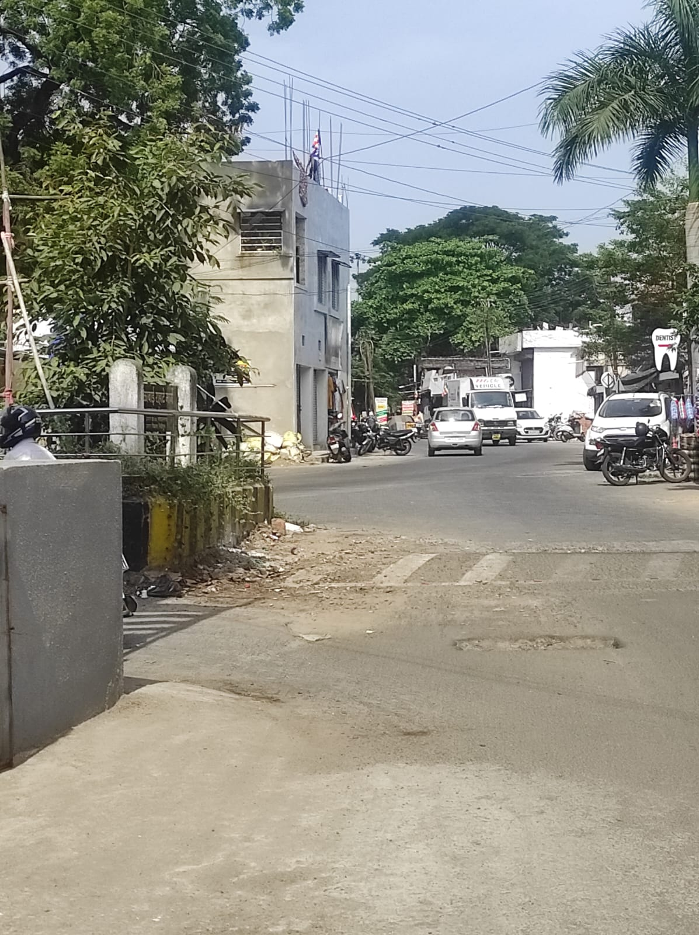

* Predicted Safety Speed: 22.796255111694336 Km/h

Good road

# Images in the Category: 40 Km/h - 80 Km/h

Image: Test_image_68.jpeg

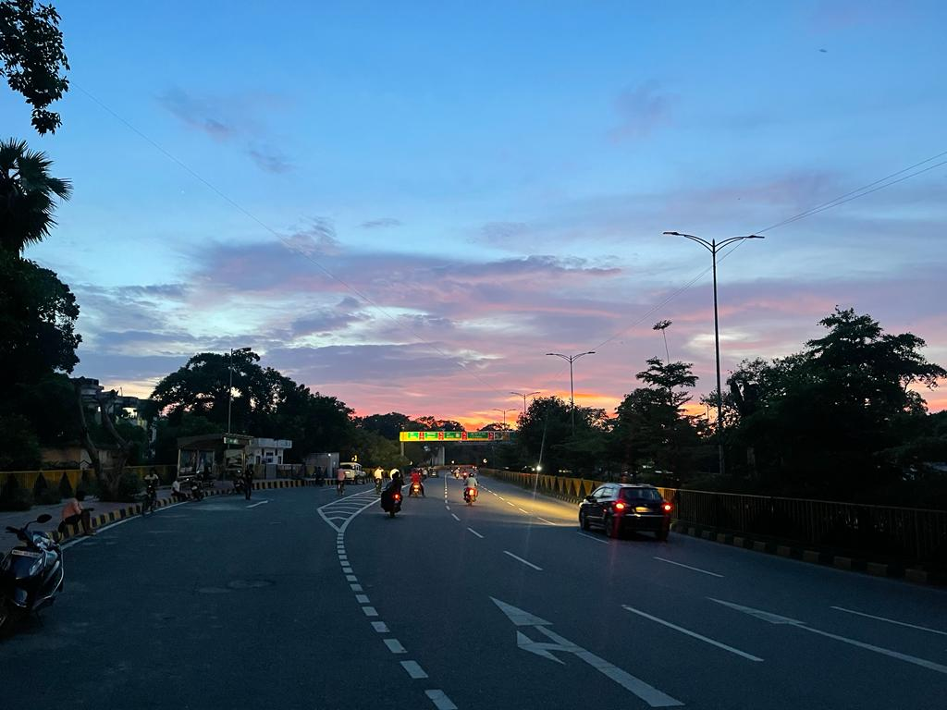

* Predicted Safety Speed: 69.78425598144531 Km/h

Good road